GROUP PROJECT: DBAS32100

Project Report

Submitted to: Dr. Tamanna Chhabra

Submitted by: DATA MASTERS

GROUP 5

JAINI BHAVESHABHAI TOPIWALA (991669857)

HARSIMRANJIT SINGH (991711378)

HARLEEN KAUR (991707028)

Date of Submission: 05 APRIL 2024

In Task A of the project we will focus on creating tables, generating CSV files, importing data using Talend and displaying data in SQL Developer. This task is essential for setting up the database and populating it with initial data.

Completed by: Jaini Bhaveshbhai Topiwala

## Creating Tables: We created tables based on the data structure provided in the Excel file GP:DBAS32100. These tables are movie_category, customer_list, dvds, and dvd_rental each with columns to store information.

## Creating movie_category table with CategoryID and CategoryName columns with specific data types.

Creating customer_list table with CustomerID, FirstName, LastName, PhoneNumber, Birthdate, DriverLicenseNumber, and Status columns with specific data types.

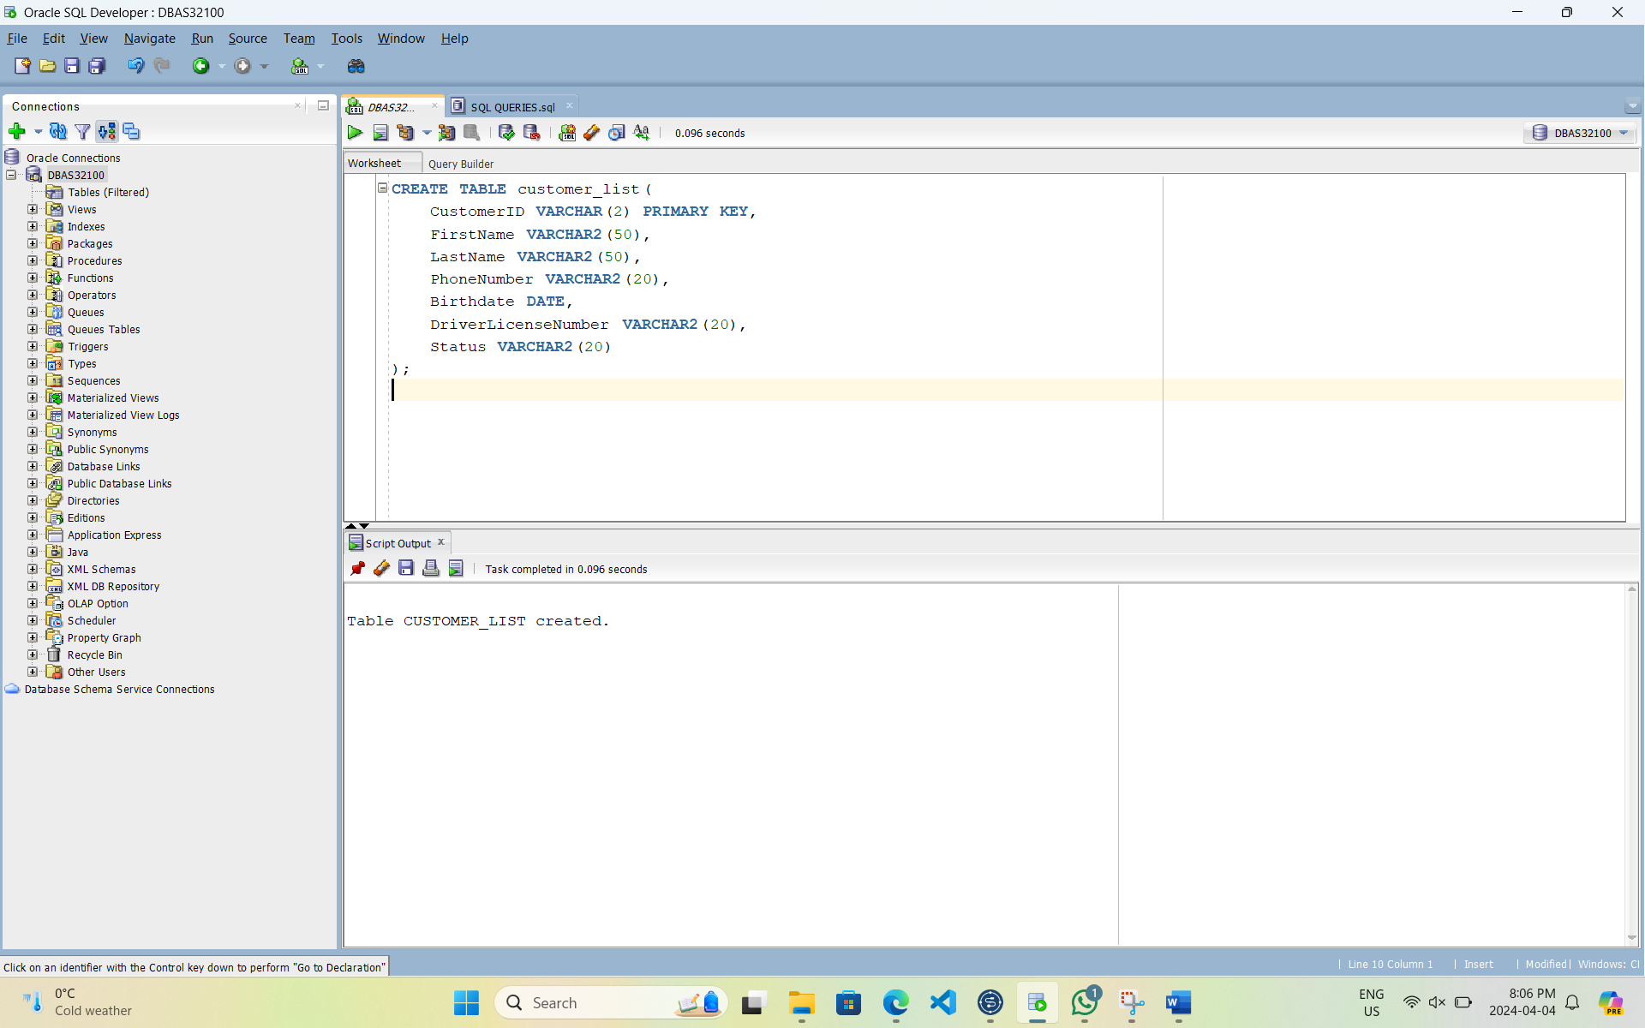

Creating dvds table with TapeID, Title, Year, Cost, CategoryID, RentedOut, Rating, and ActionOnReturn columns with specific data types.

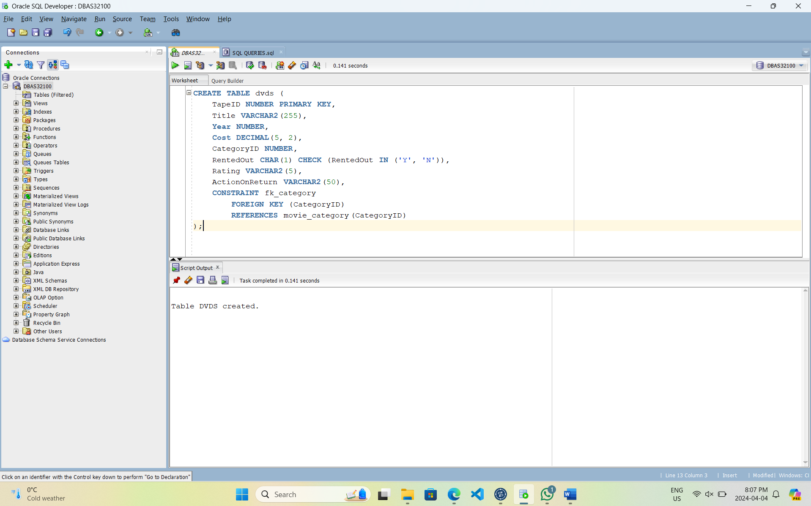

Creating dvd_rental table with RentalID, RentalDate, CustomerID, and TapeID columns with specific data types.

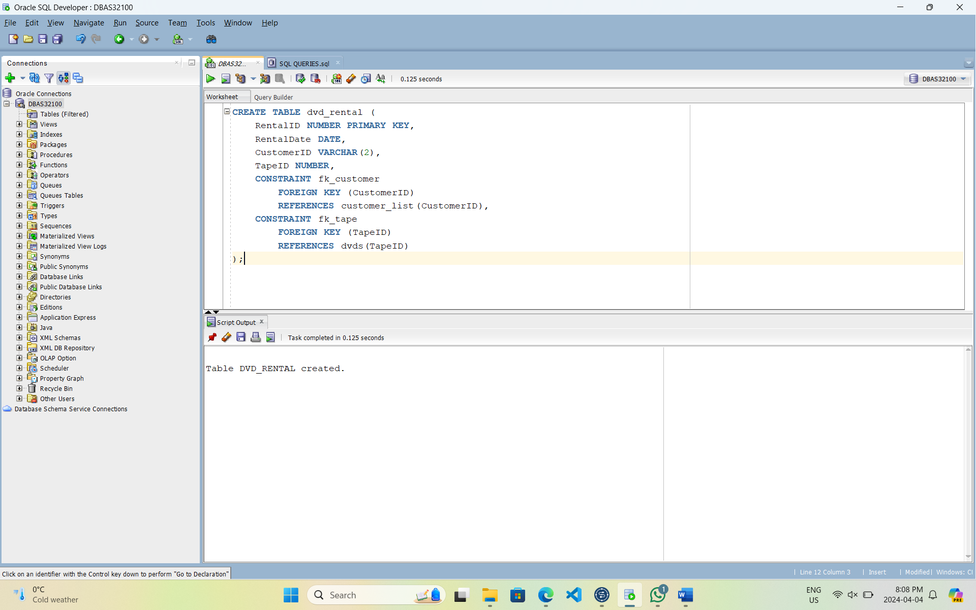

## Creating Connection: We established a database connection using Talend Open Studio, inputting essential details like database type, host, and credentials, username and password. This connection enables seamless data retrieval and manipulation, crucial for our project's success and database interaction.

Database Name and Purpose Selection: DBAS32100

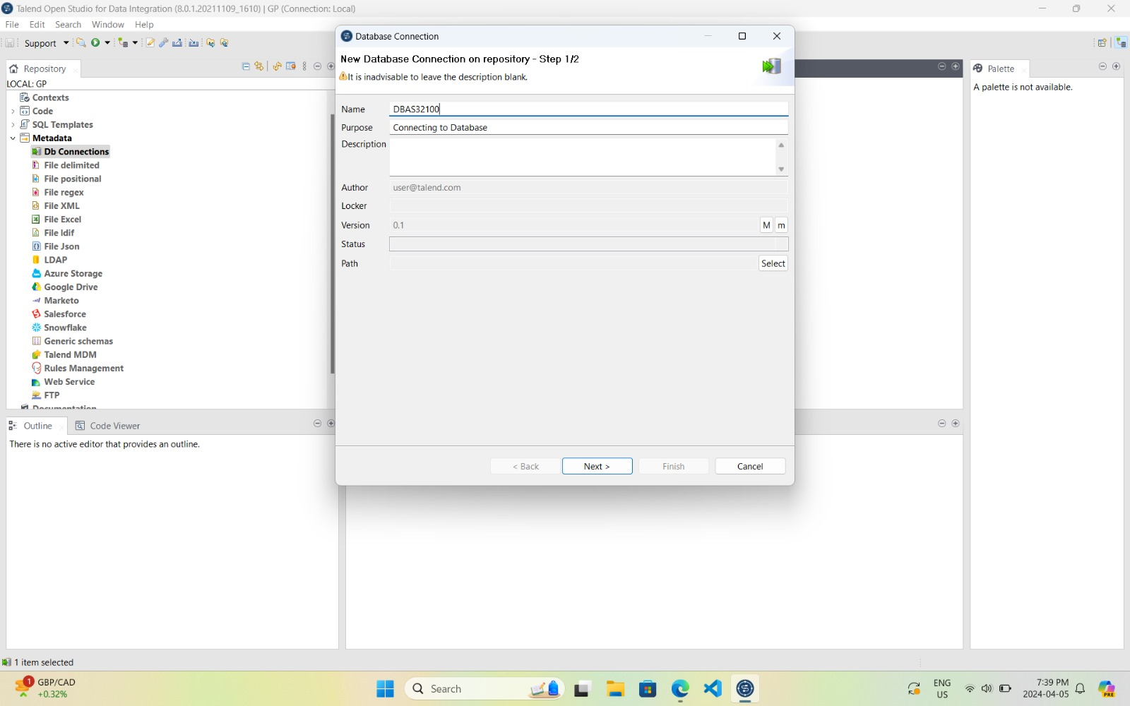

Connection Settings Configuration

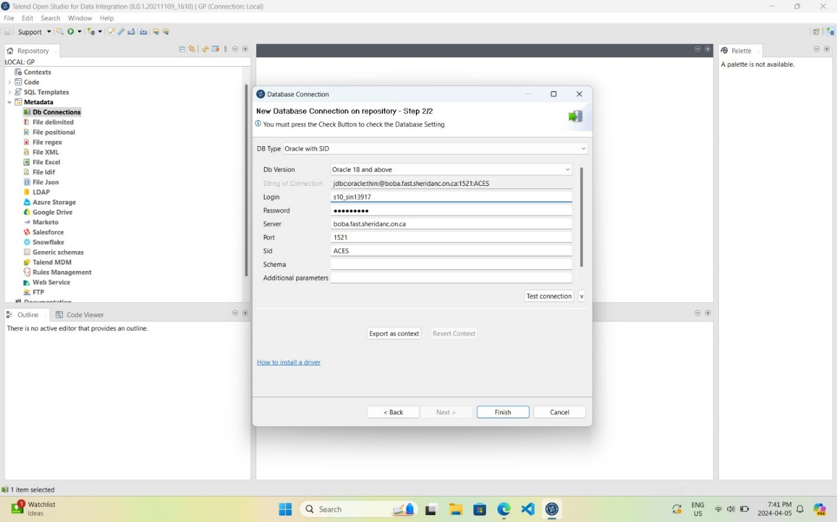

Testing Connection and Connection Established

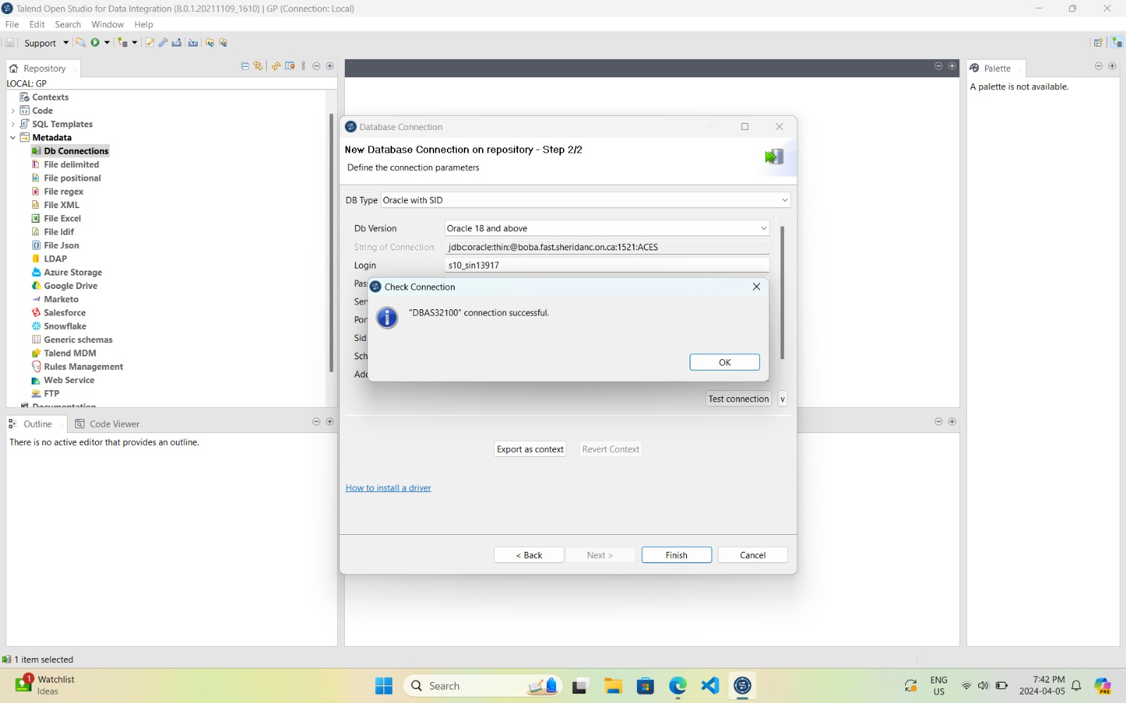

Retrieving Schema from Database: Using Talend retrieved the database schema of our database

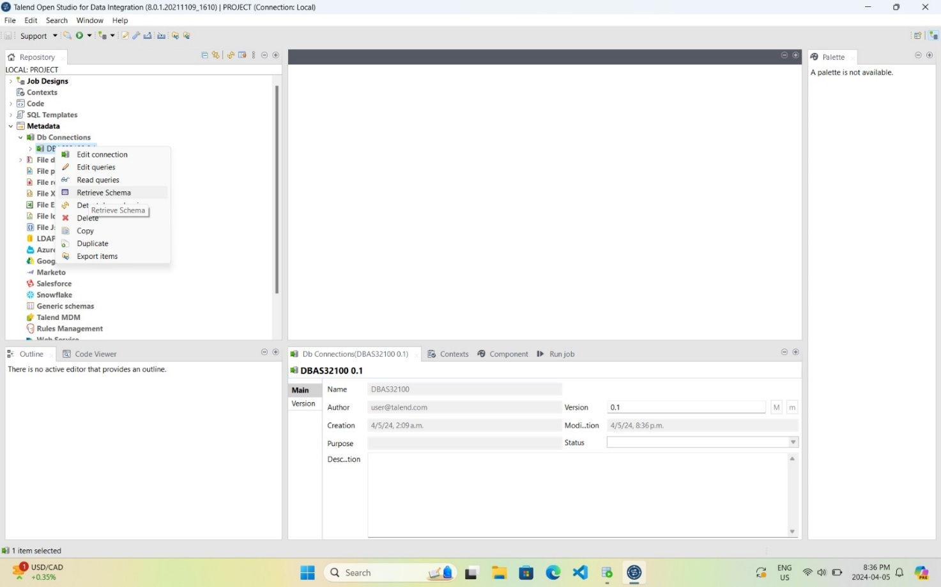

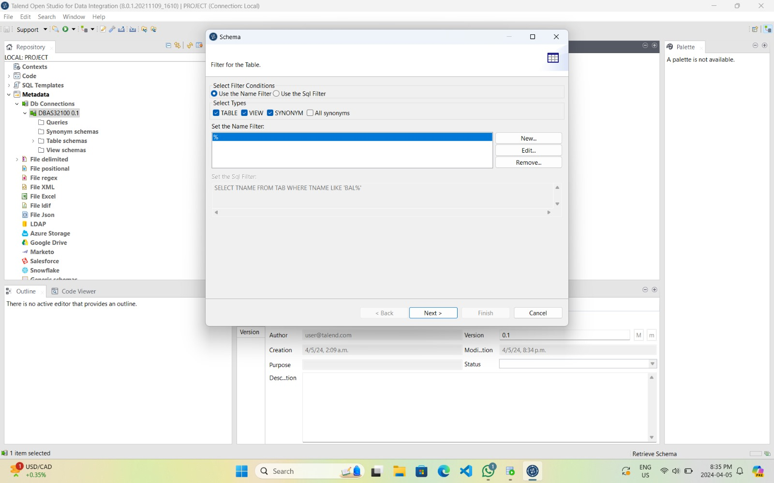

Selecting only the specific tables needed for this project.

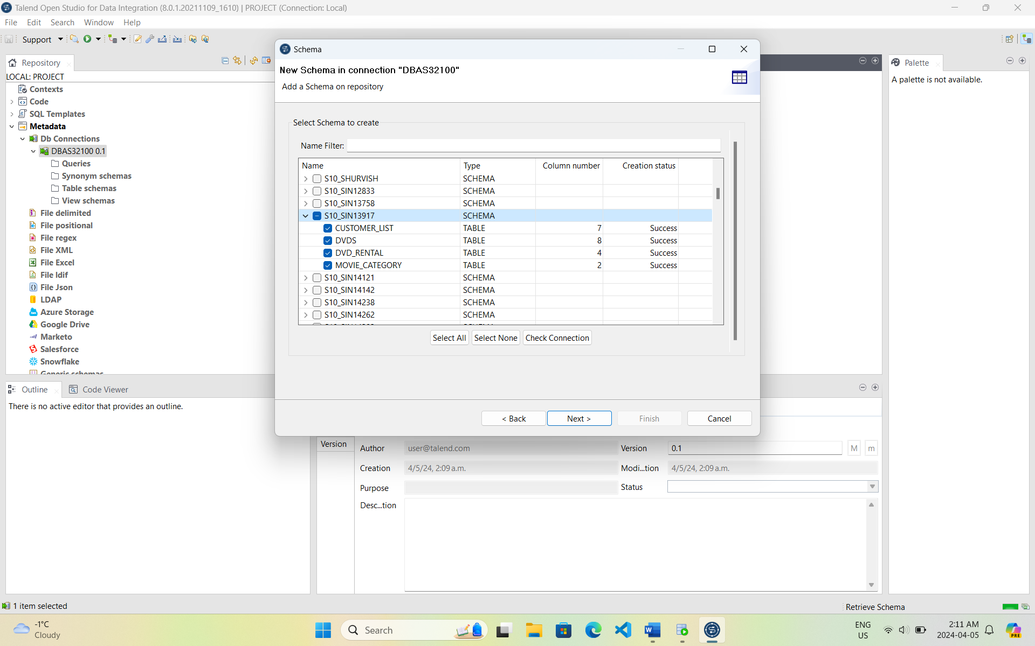

Dvd_rental Schema Retrieval

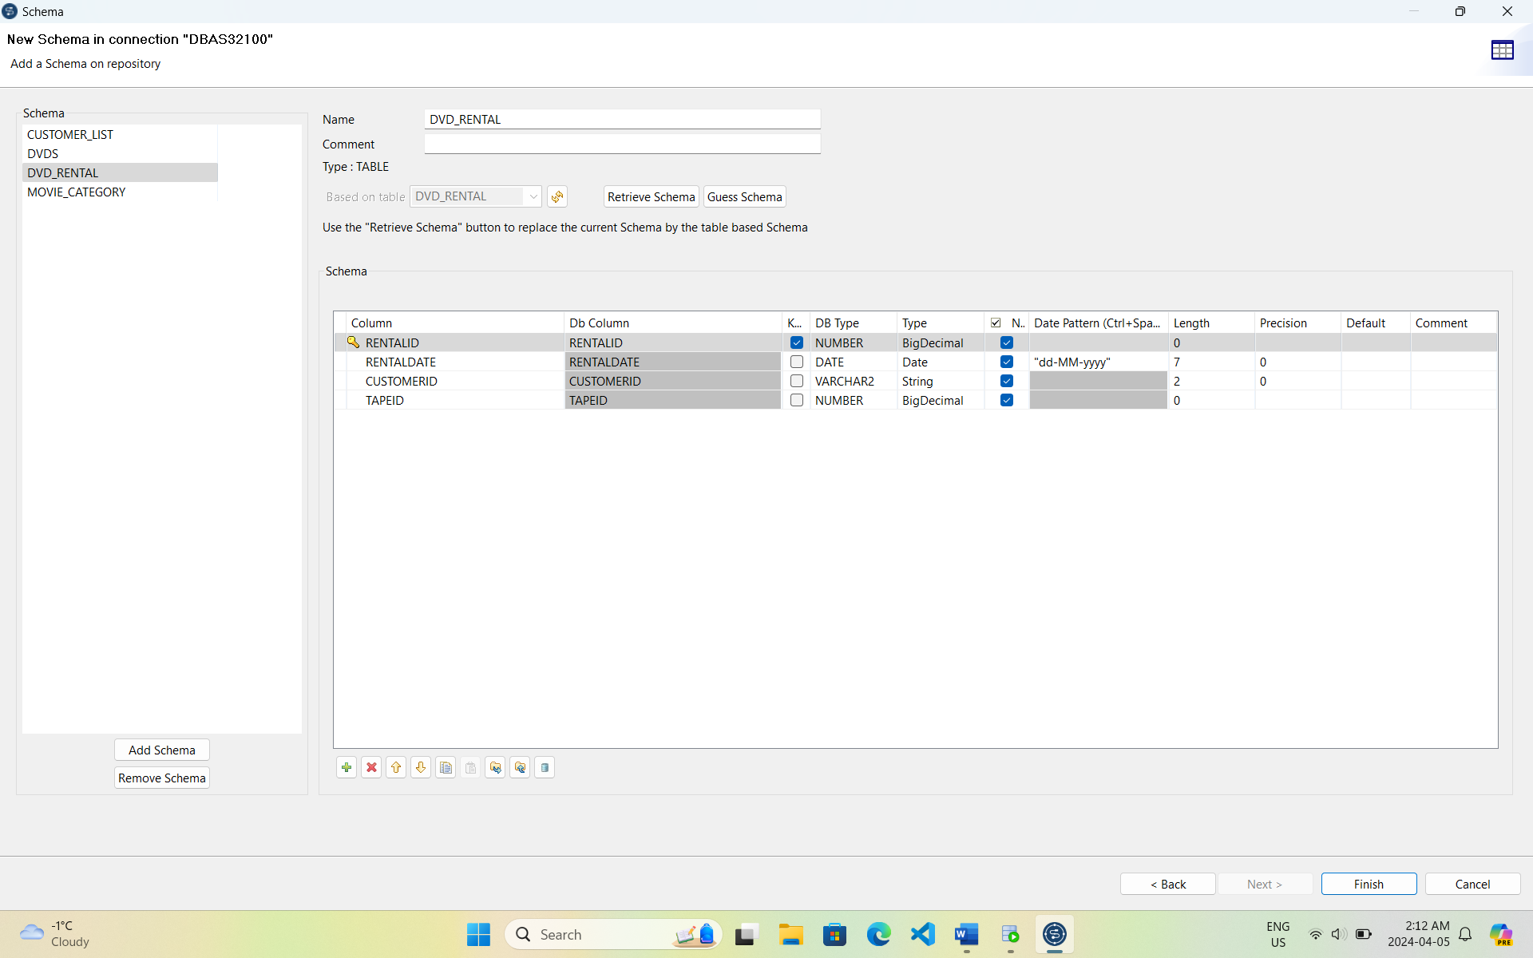

Movie_category Schema Retrieval

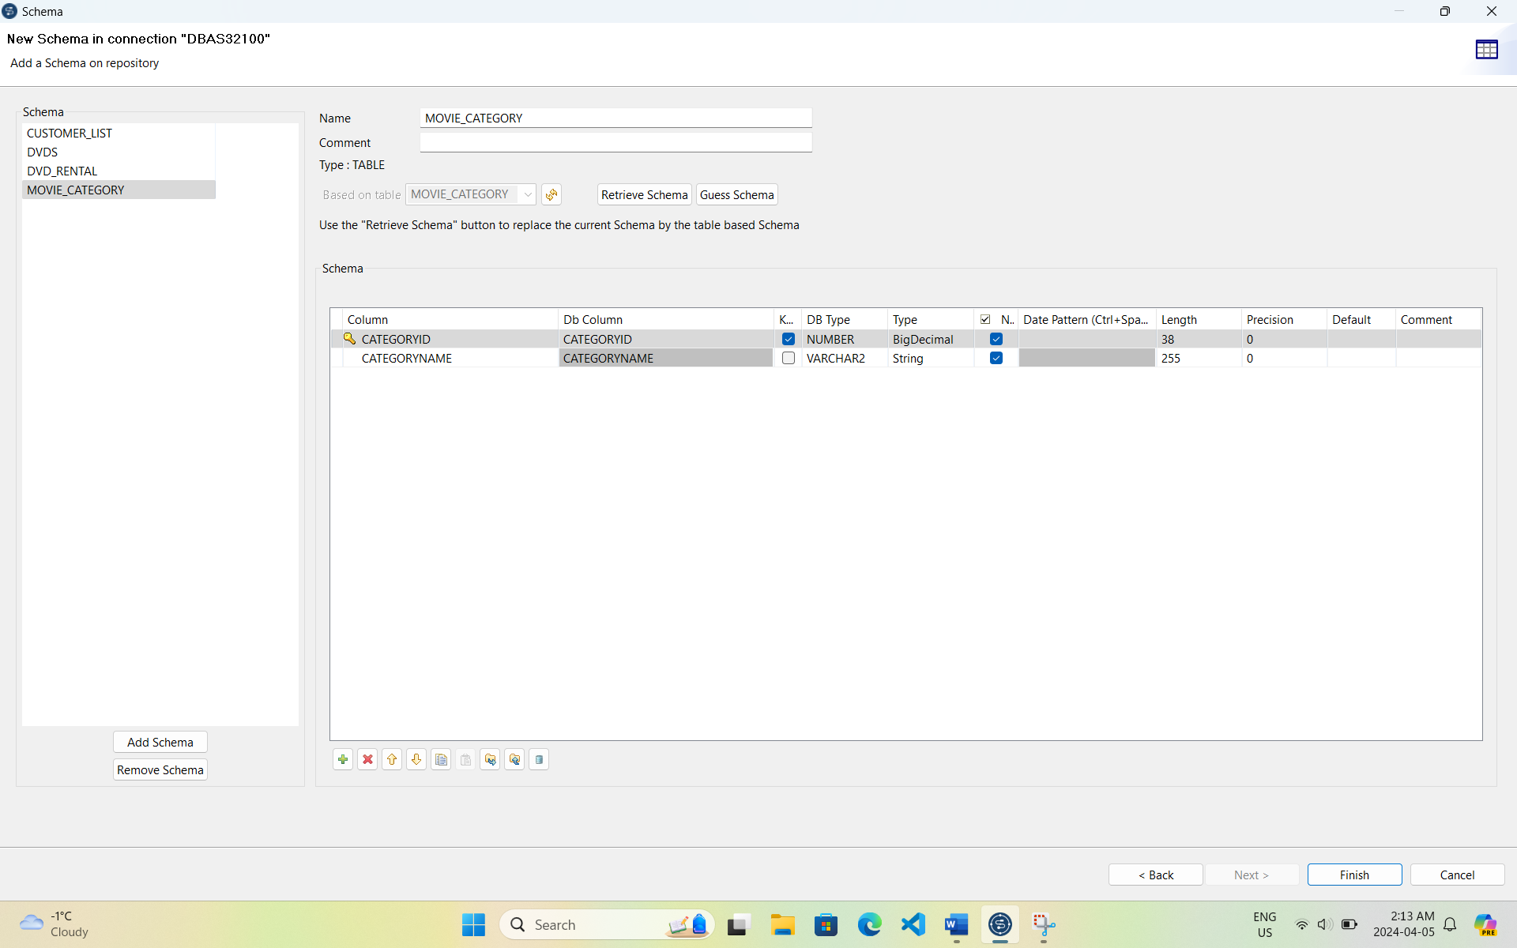

Customer_list Schema Retrieval

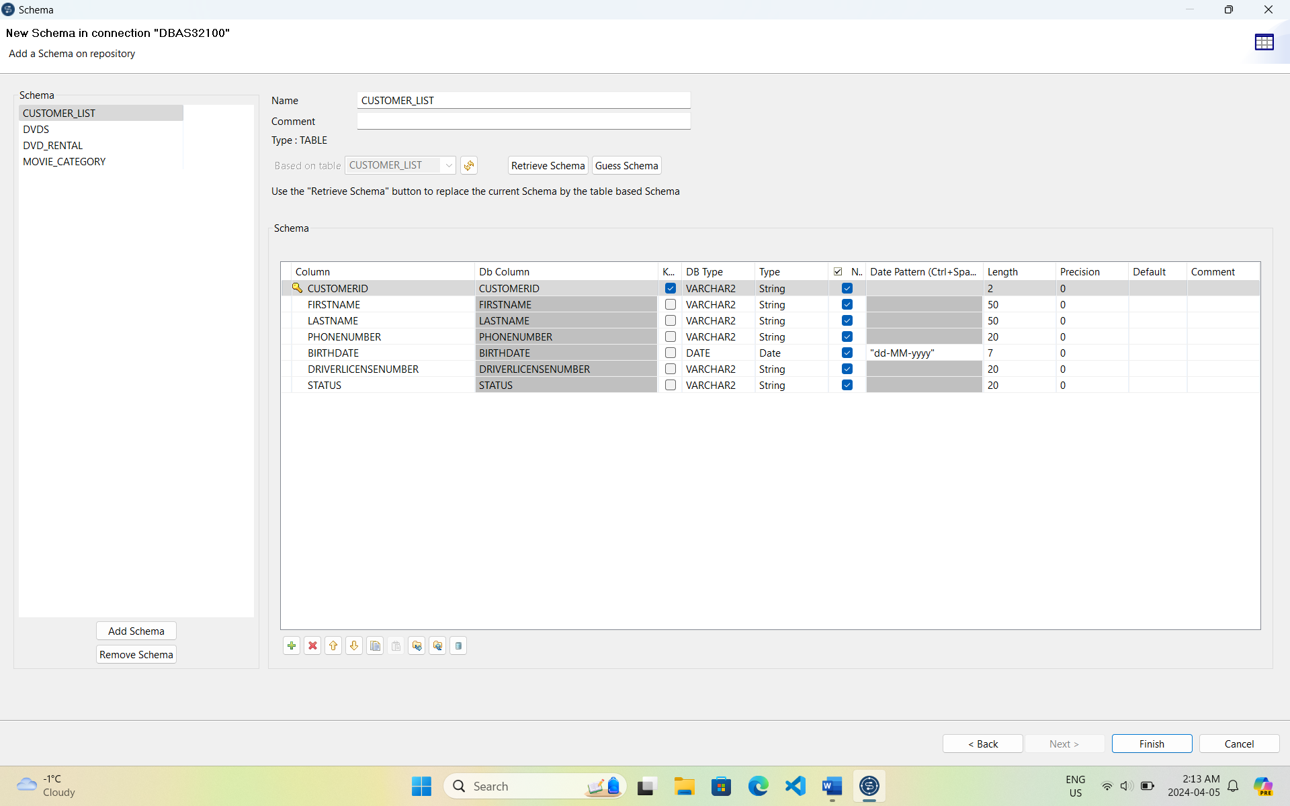

DVDs Schema Retrieval

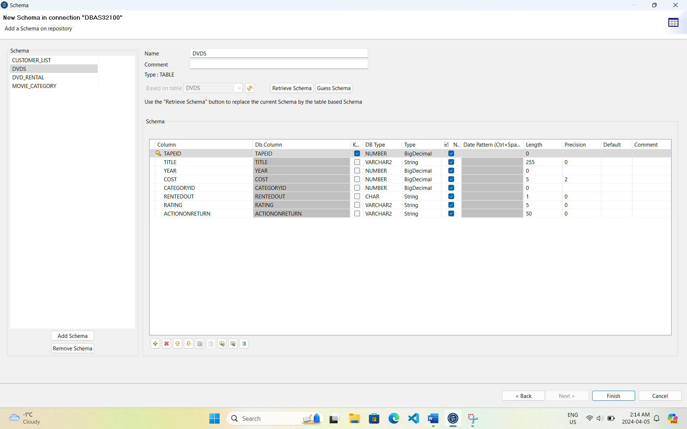

## Generating CSV Files: After creating the tables we generated CSV files for each table containing sample data. These CSV files will serve as input for the data import process using Talend Open Studio.

## Imported Data using Talend: Using Talend Open Studio we designed a job to extract data from the CSV files and load it into the corresponding tables in the DBAS32100 database.

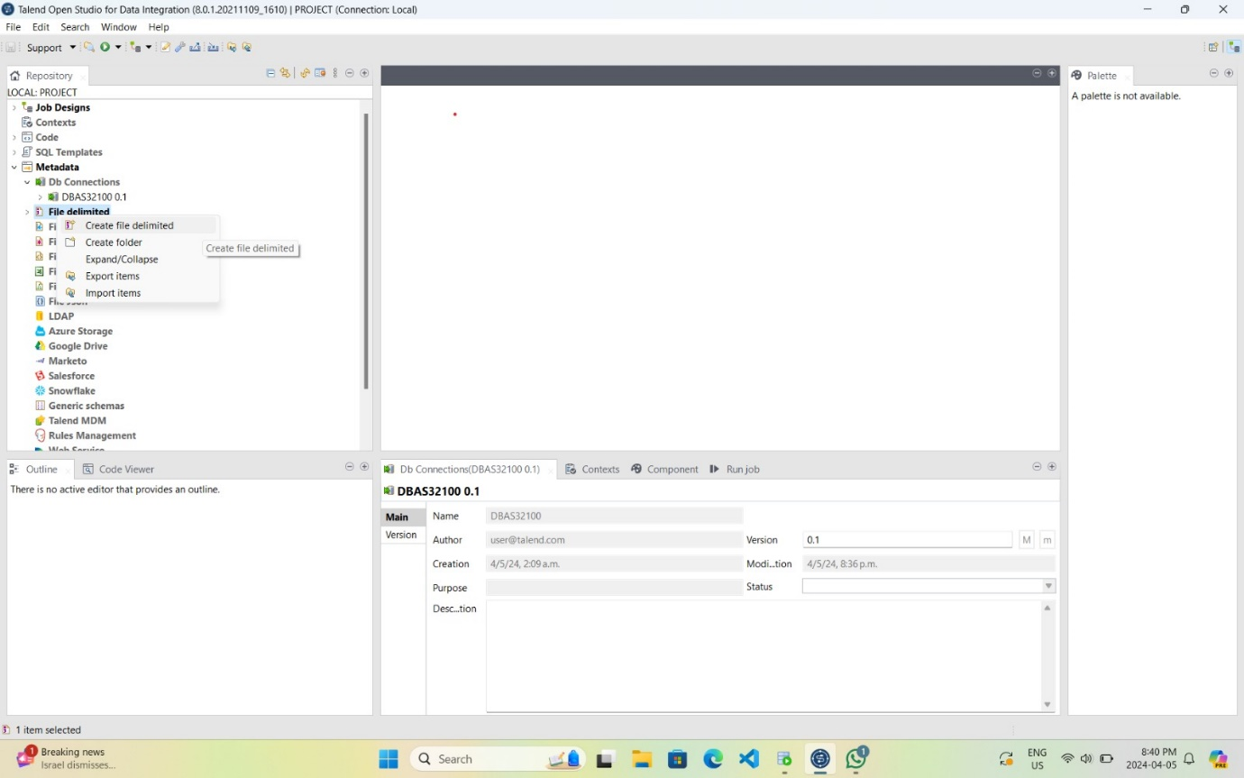

Creating Delimited File for Customer_List Table

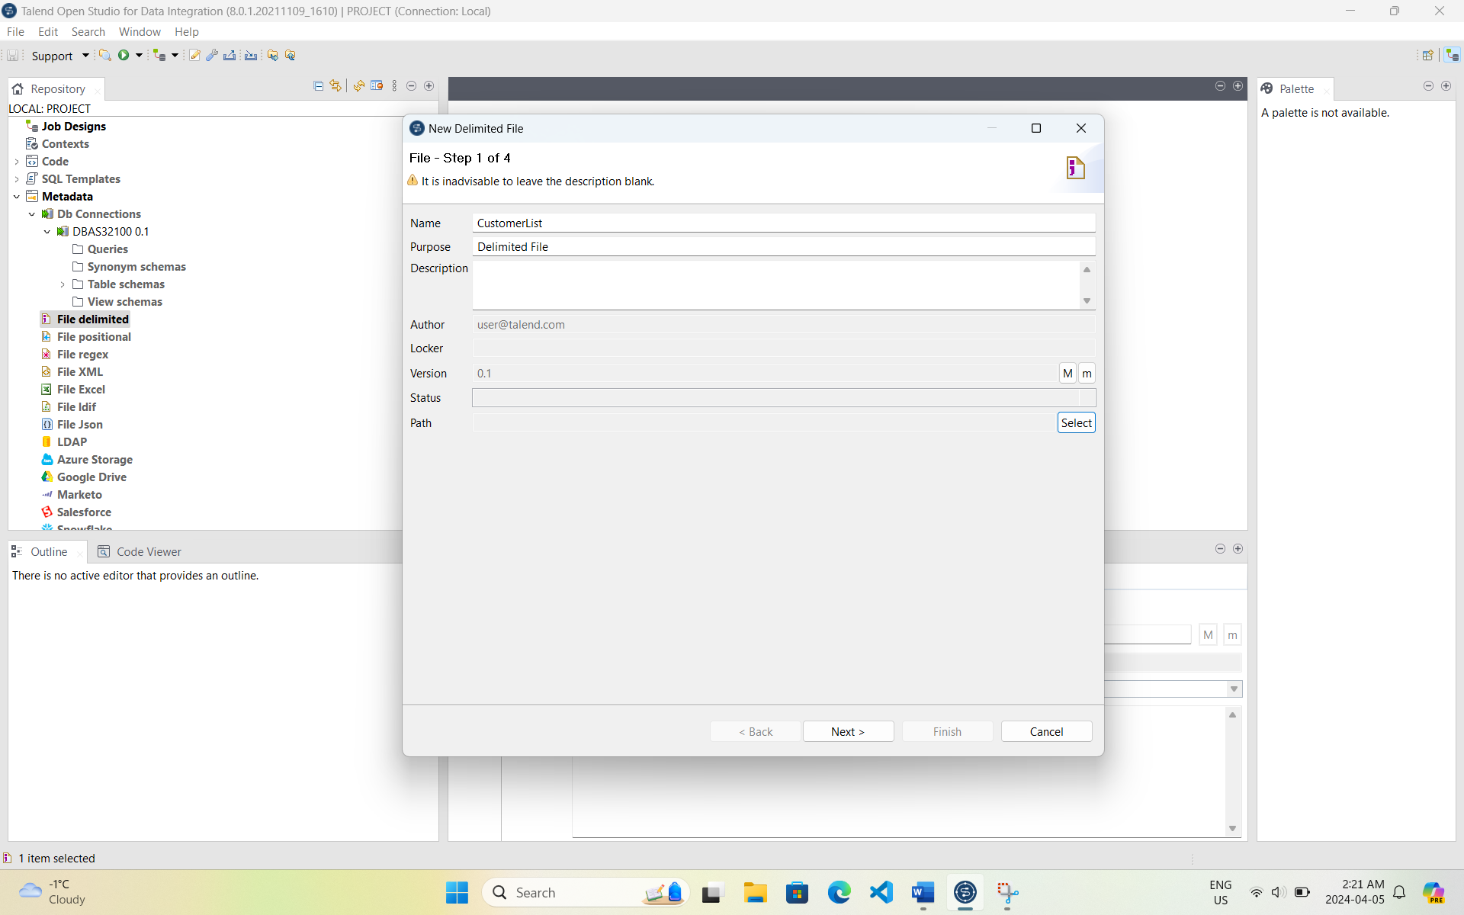

Configuring Delimited File Settings for Customer_List Table

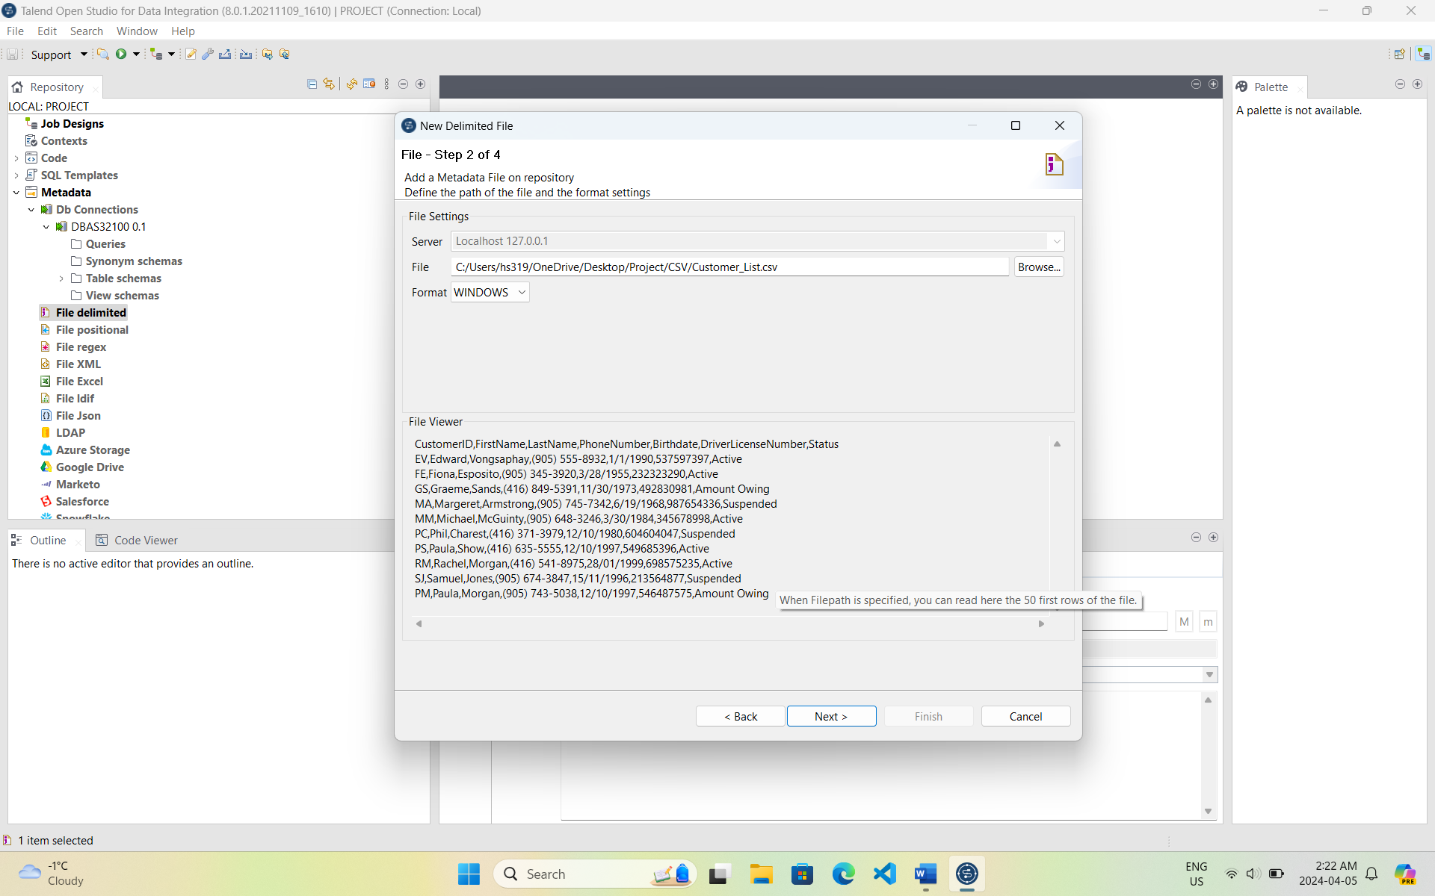

Displaying Preview Data for Customer_List Table

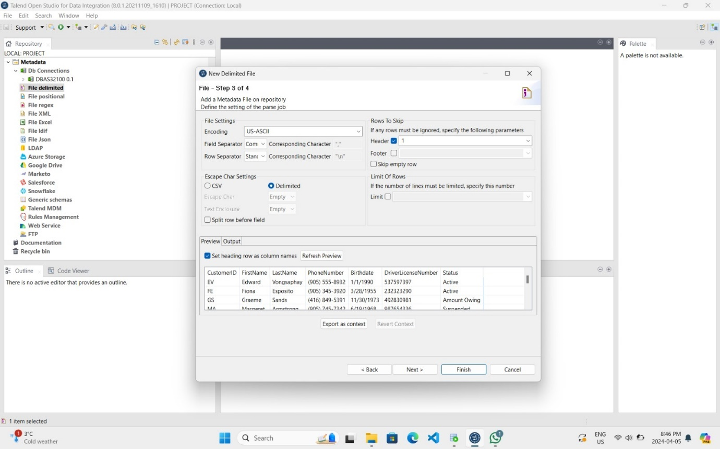

Confirming and Finishing Delimited File Setup for Customer_List Table

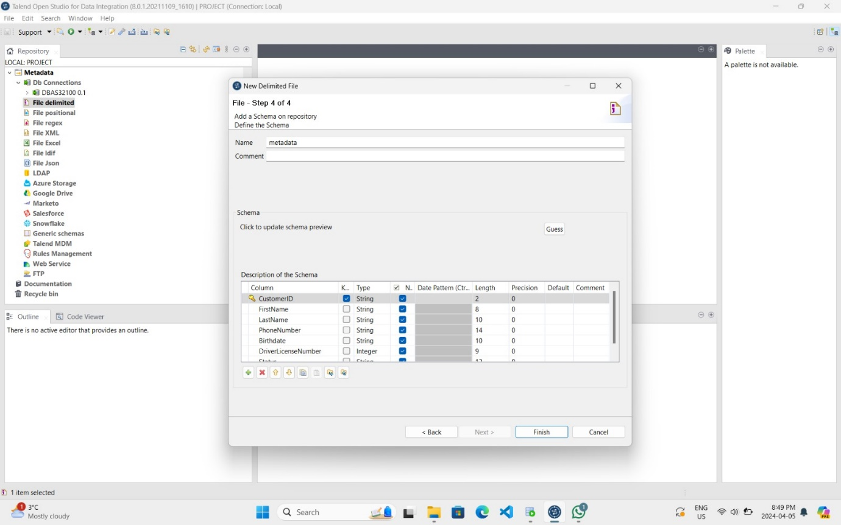

Creating Delimited File for DVDs Table

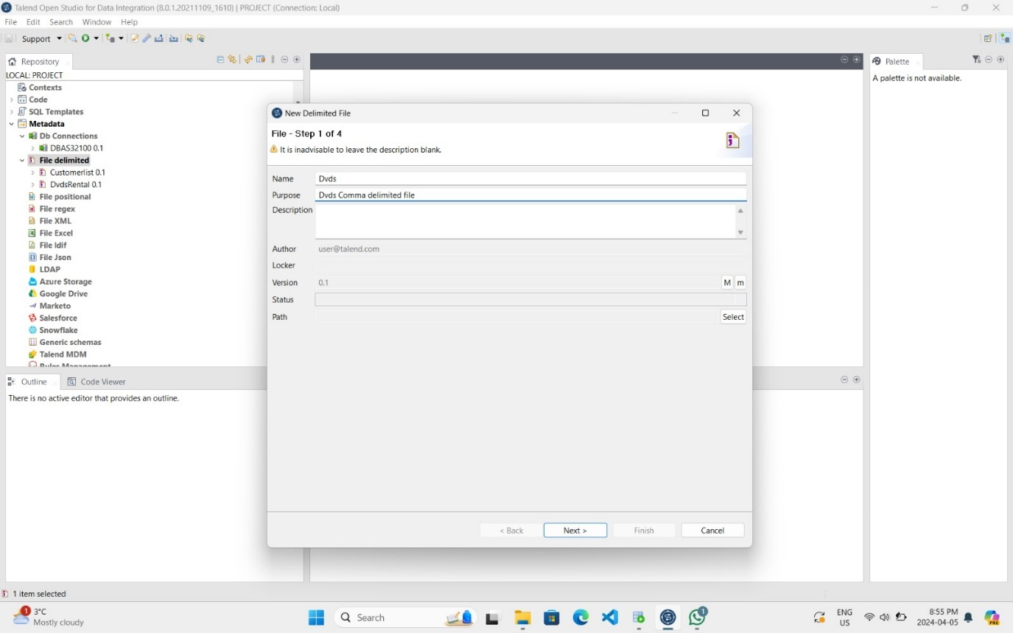

Configuring Delimited File Settings for DVDs Table

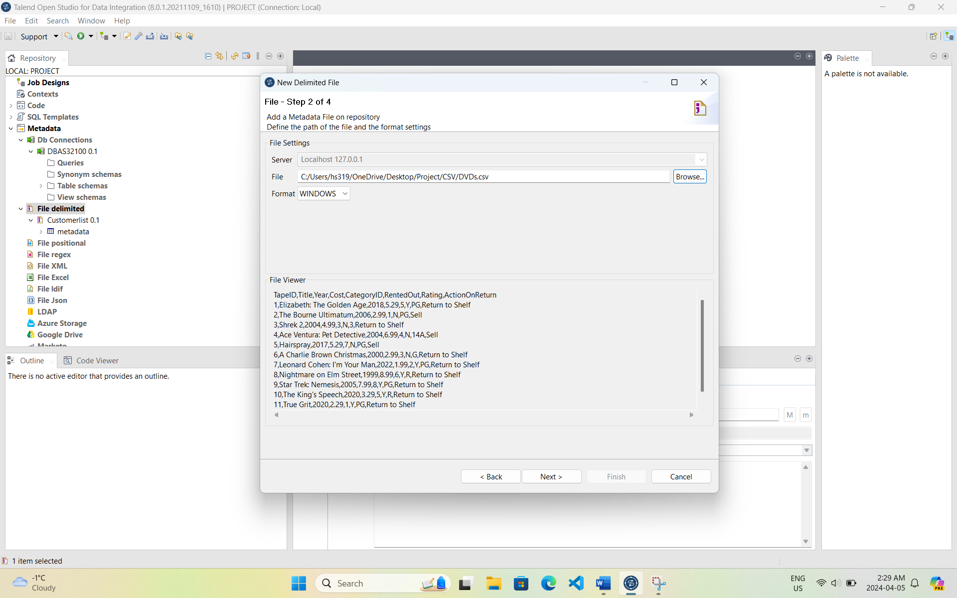

Displaying Preview Data for DVDs Table

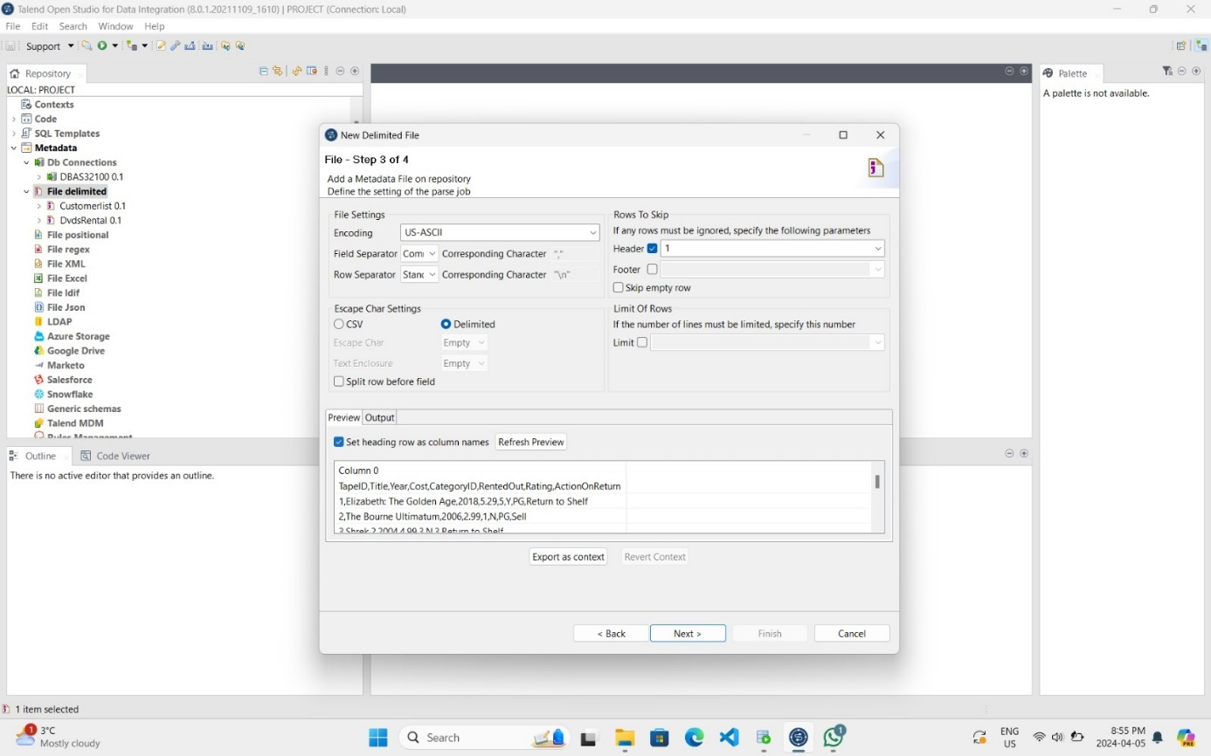

Confirming and Finishing Delimited File Setup for DVDs Table

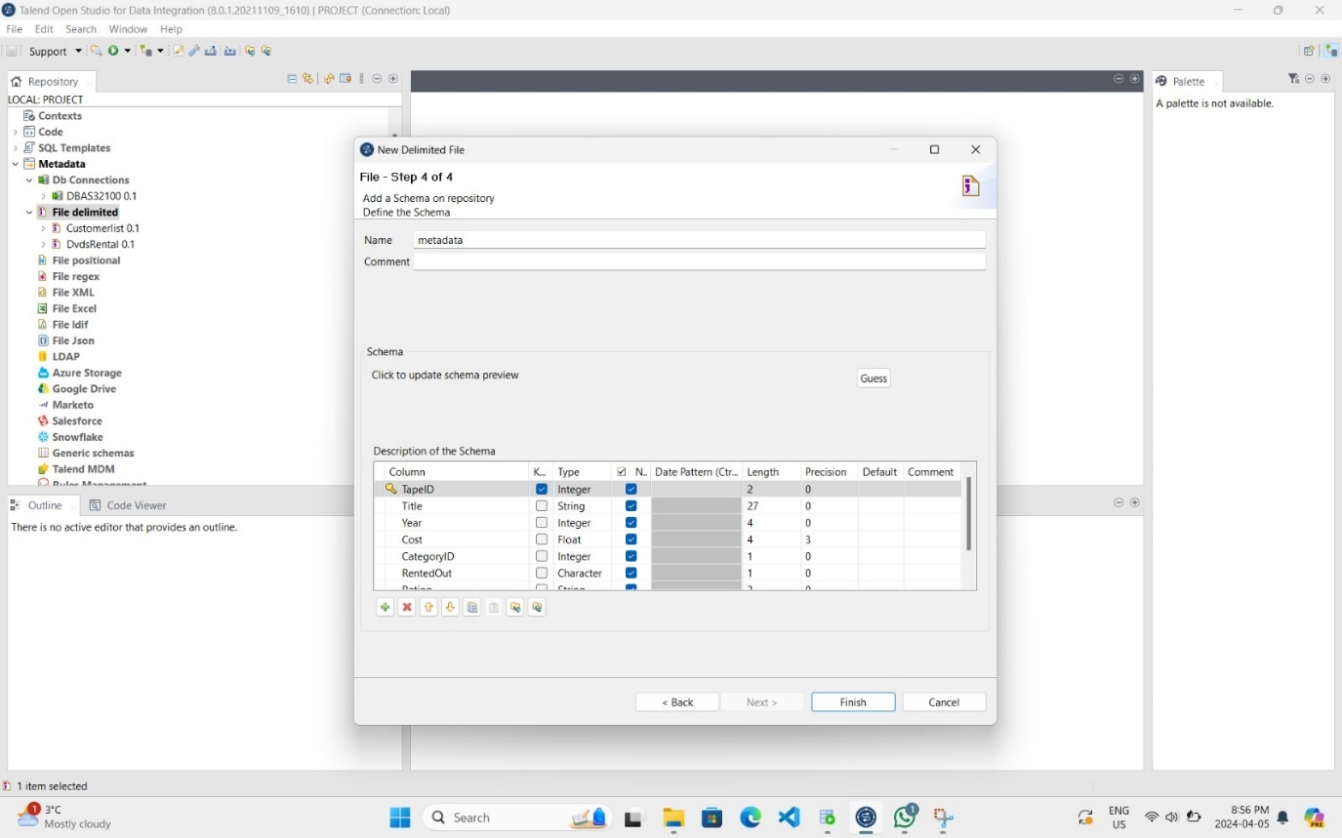

Creating Delimited File for DVD_Rental Table

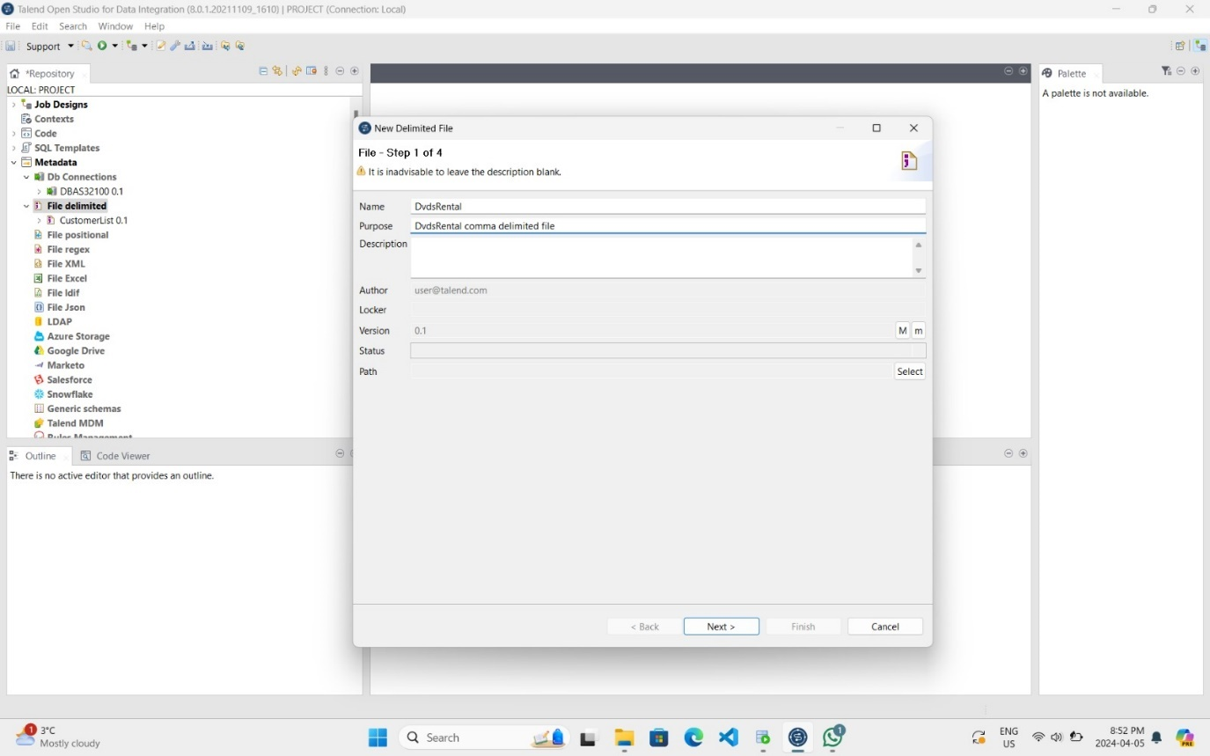

Configuring Delimited File Settings for DVD_Rental Table

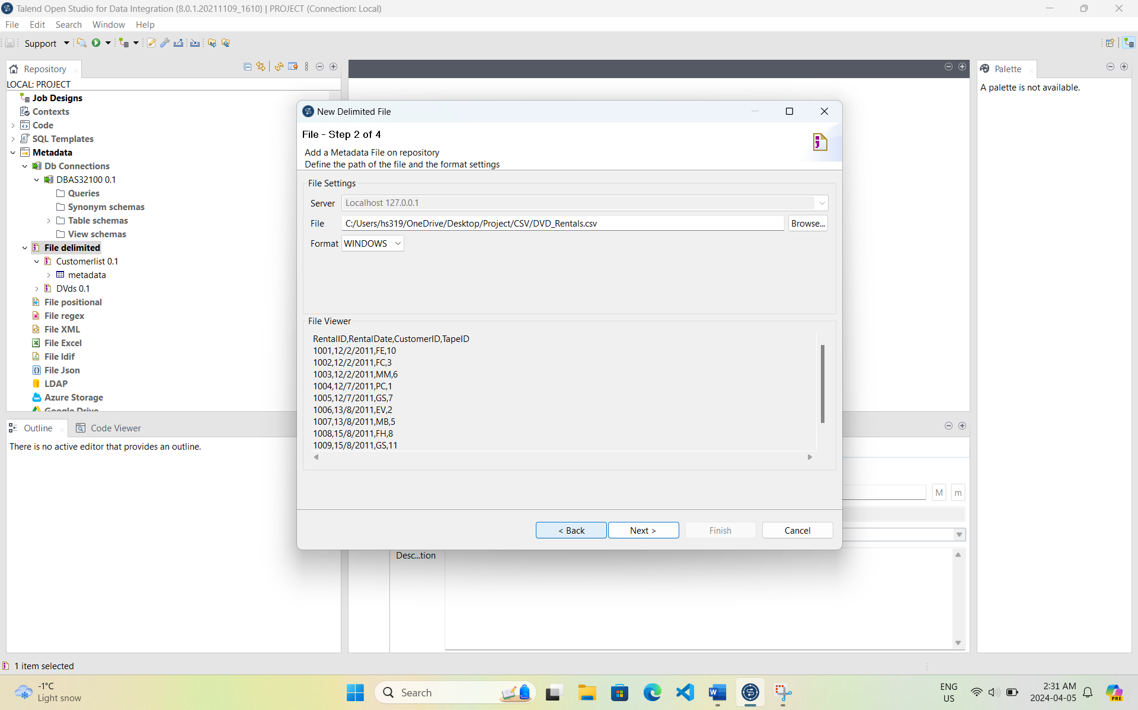

Displaying Preview Data for DVD_Rental Table

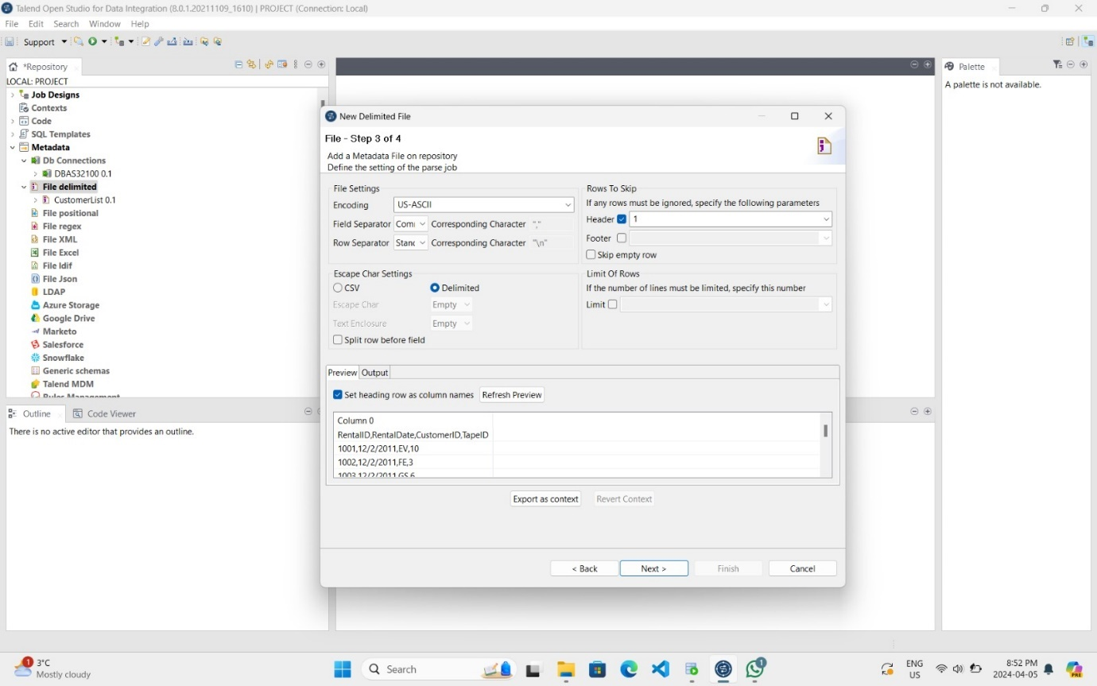

Confirming and Finishing Delimited File Setup for DVD_Rental Table

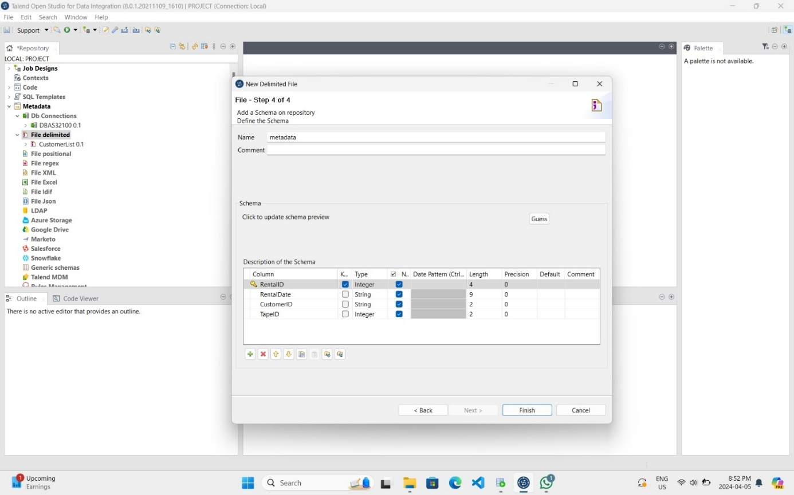

Creating Delimited File for Movie_Category Table

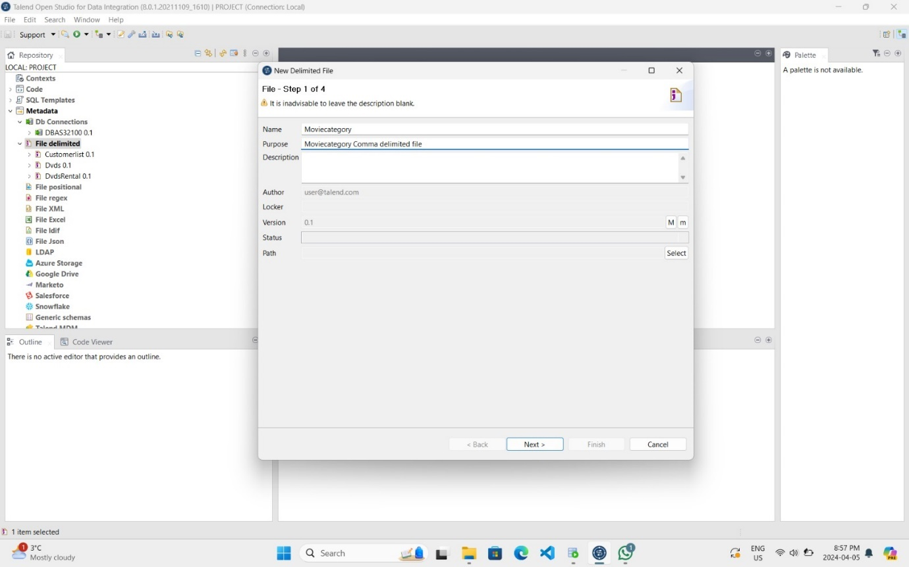

Configuring Delimited File Settings for Movie_Category Table

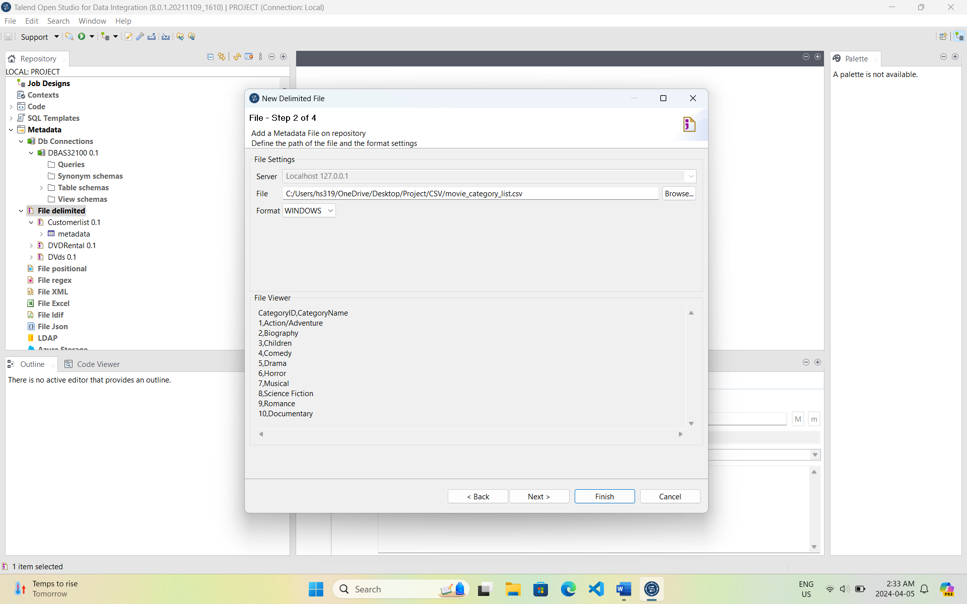

Displaying Preview Data for Movie_Category Table

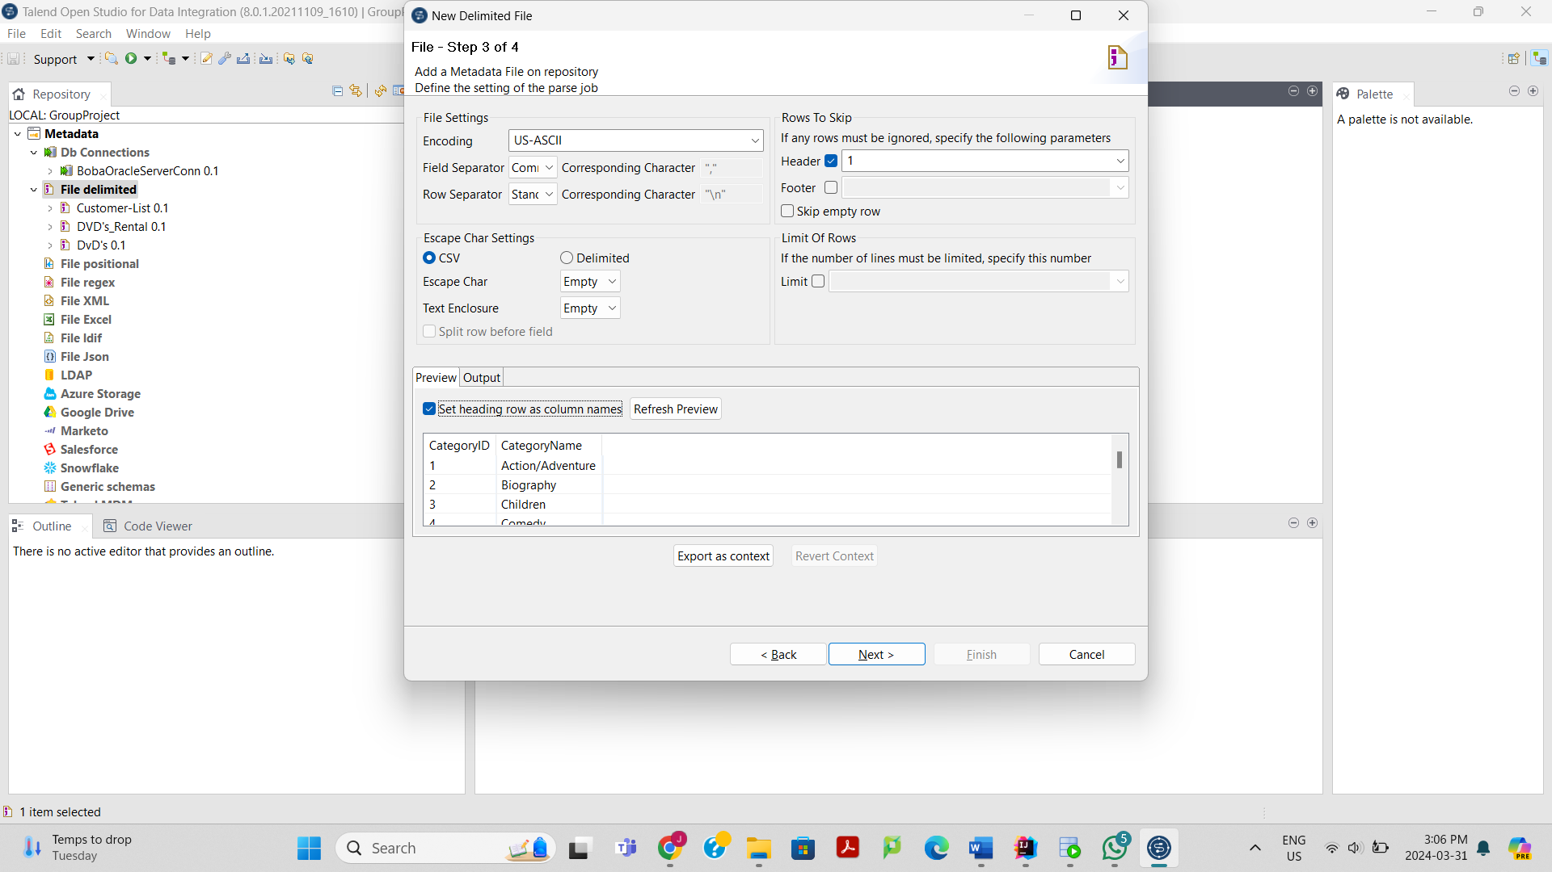

Confirming and Finishing Delimited File Setup for Movie_Category Table

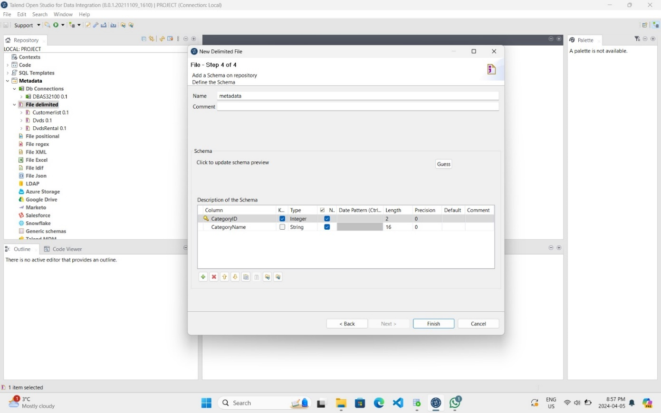

## Connecting Delimited Files to Database Tables: In this process we linked CSV files to database tables using tMap in Talend. Each table like Movie_Category undergoes steps such as dragging files, connecting them in tMap, and running the job.

Mapping Delimited Files to Movie_Category Table and Oracle Output

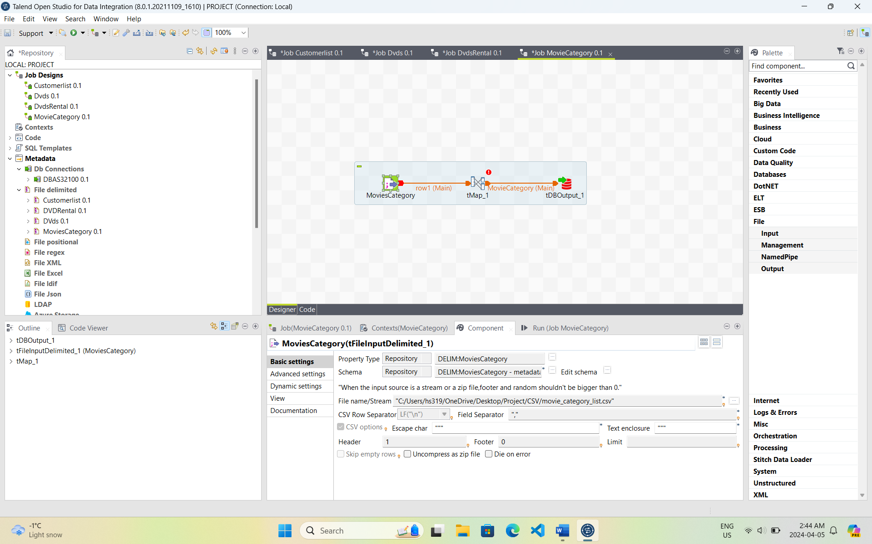

Connecting Delimited File and Table in tMap for Movie_Category Table

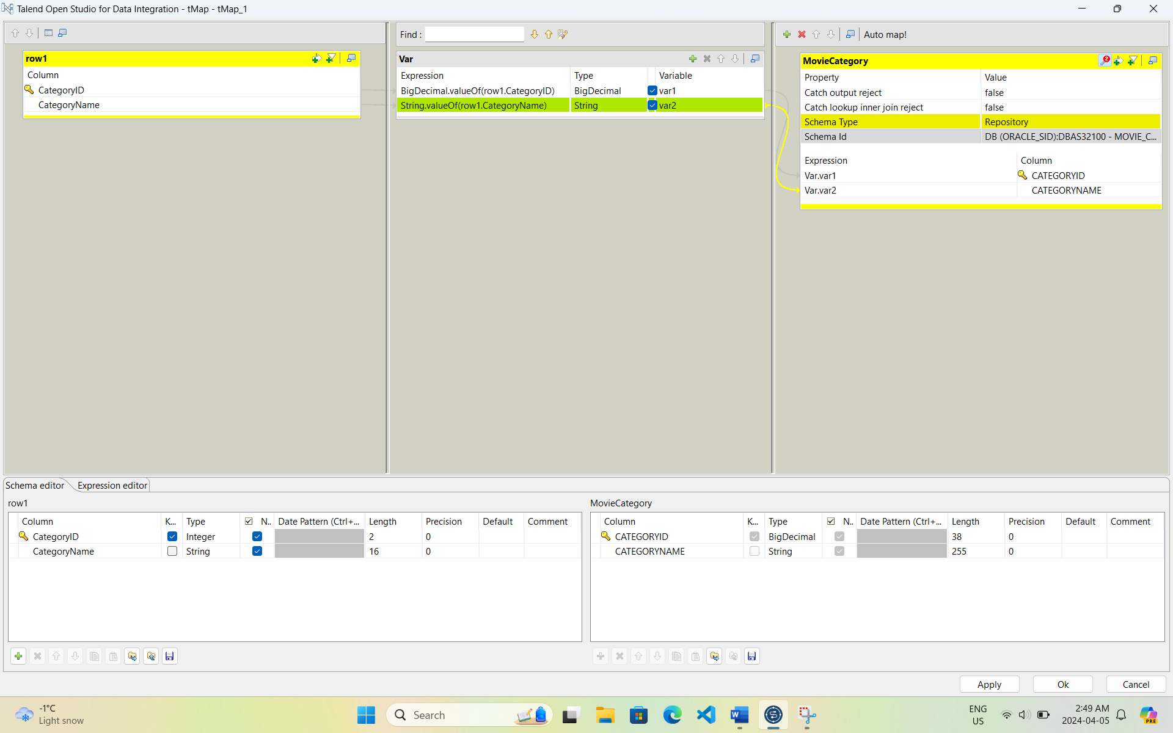

Running the Job for Movie_Category Table

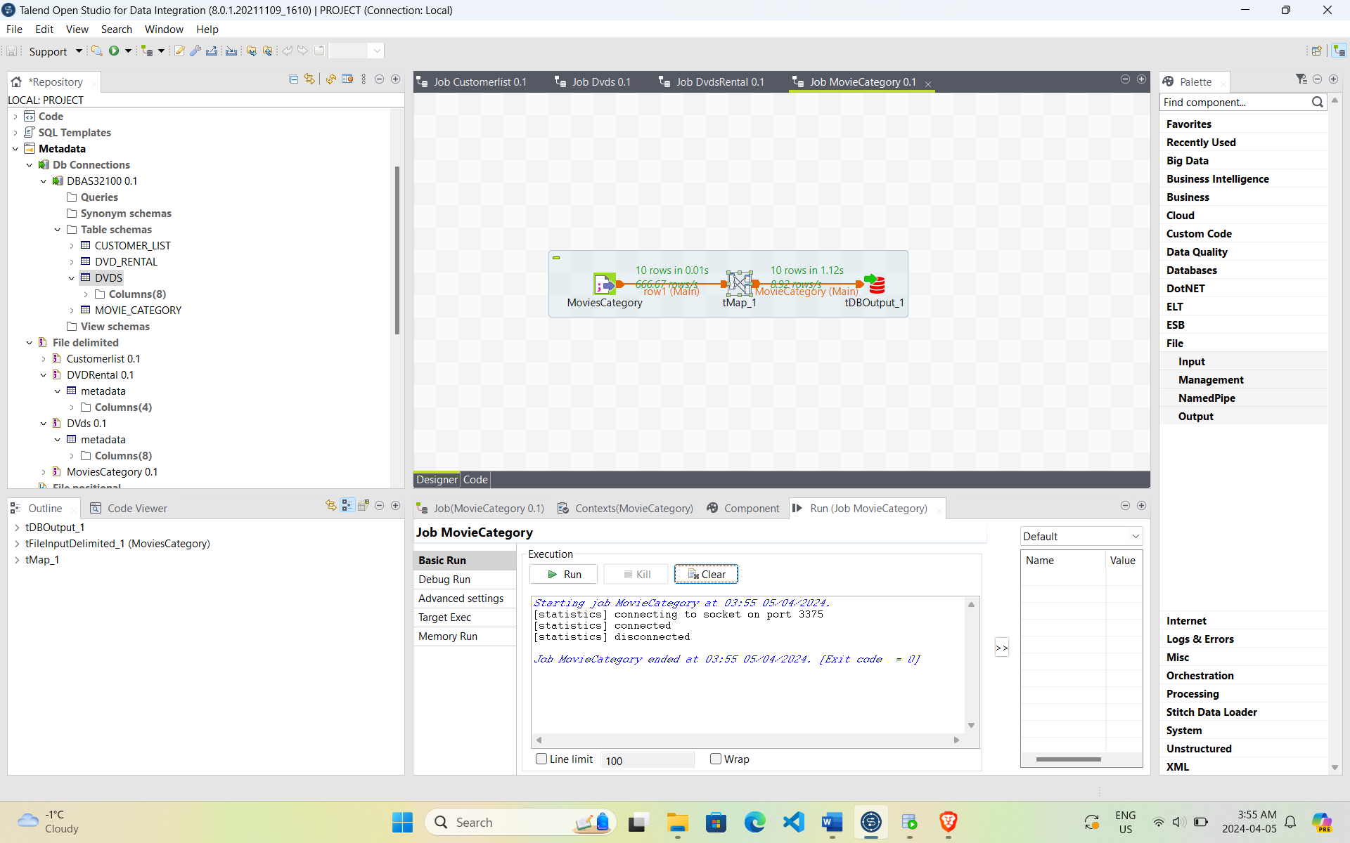

Mapping Delimited Files to DVDs Table and Oracle Output

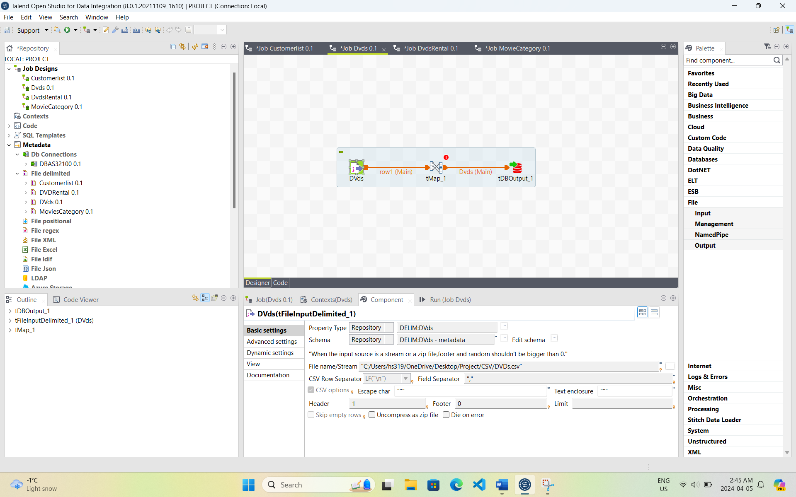

Connecting Delimited Files and Tables in tMap for DVDs Table

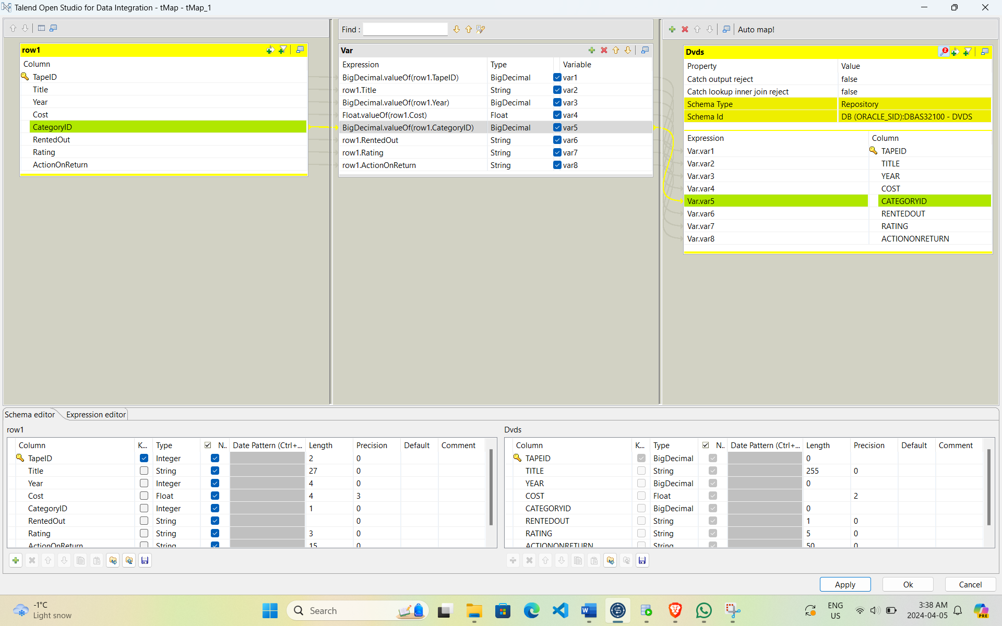

Running the Job for DVDs Table

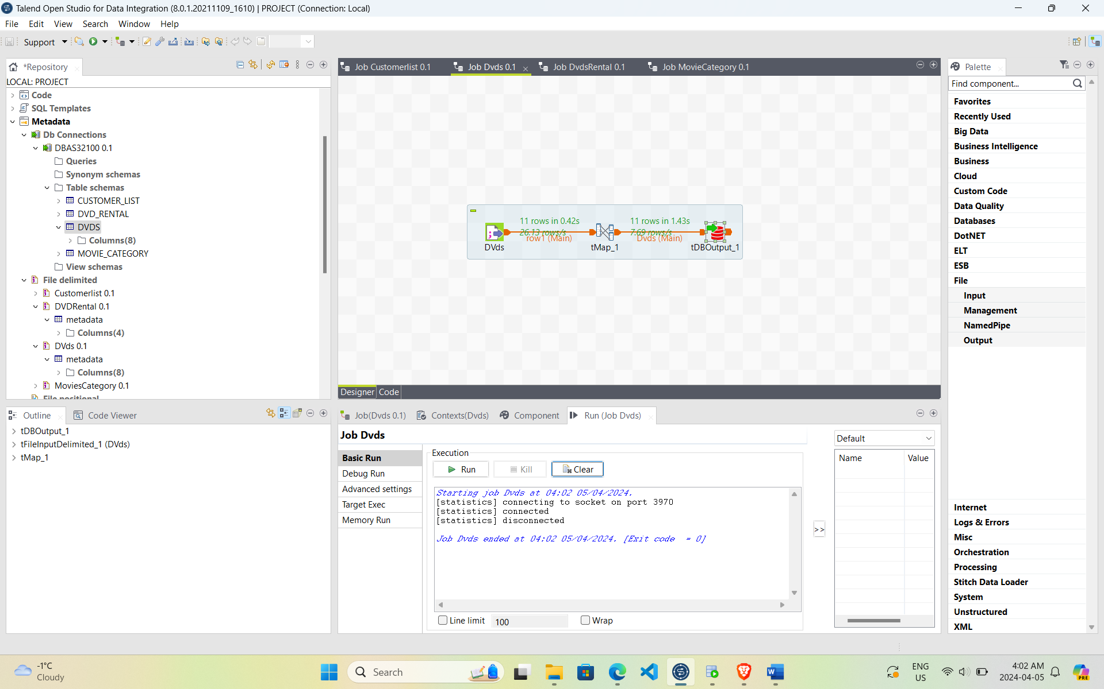

Mapping Delimited Files to DVD_Rental Table and Oracle Output

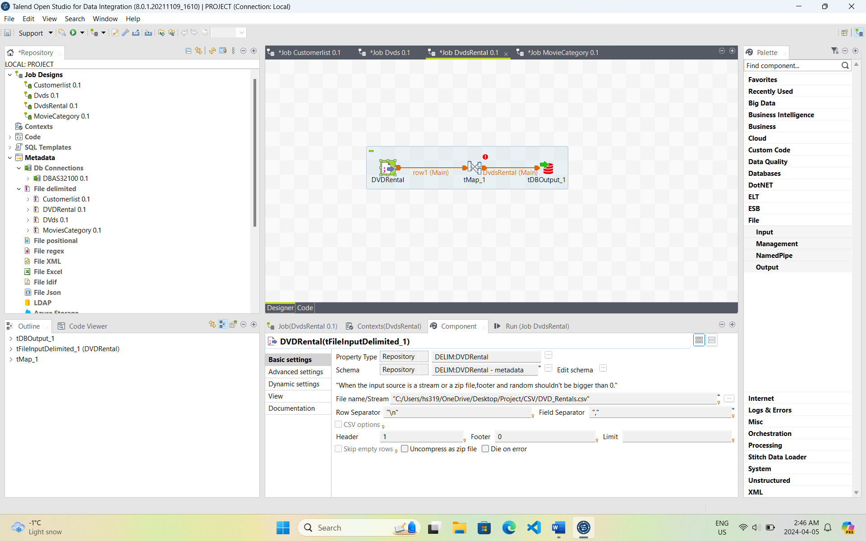

Connecting Delimited Files and Tables in tMap for DVD_Rental Table

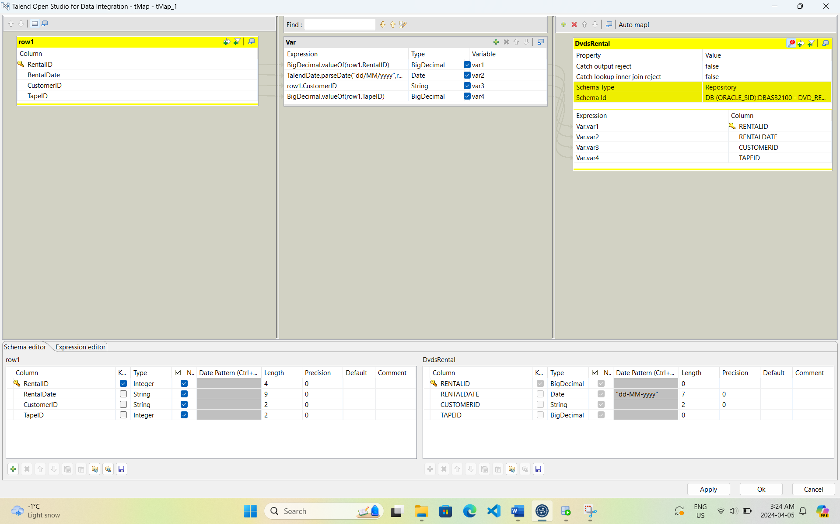

Running the Job for DVD_Rental Table

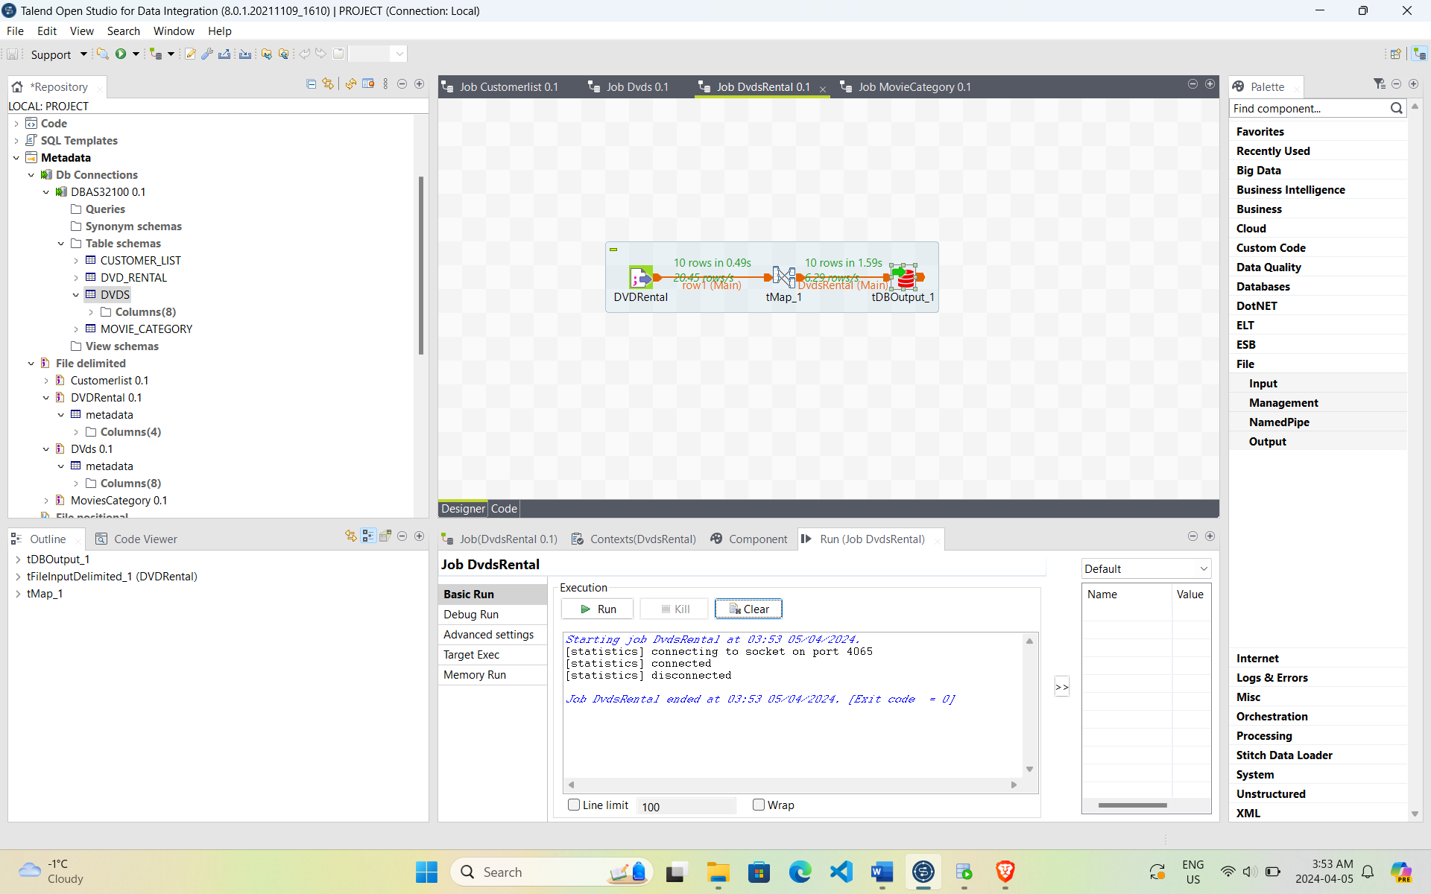

Mapping Delimited Files to Customer_List Table and Oracle Output

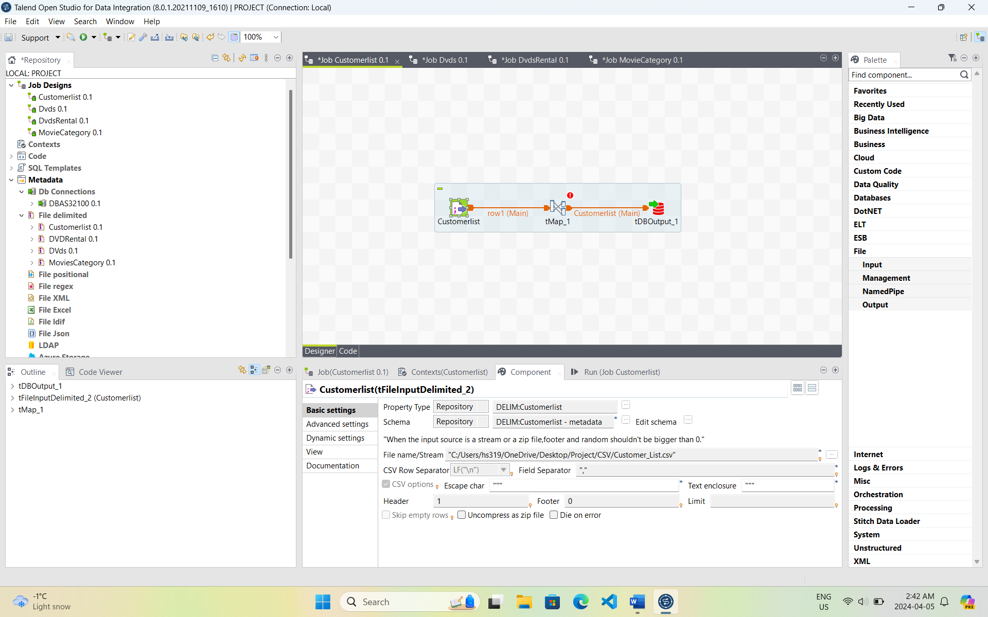

Connecting Delimited Files and Tables in tMap for Customer_List Table

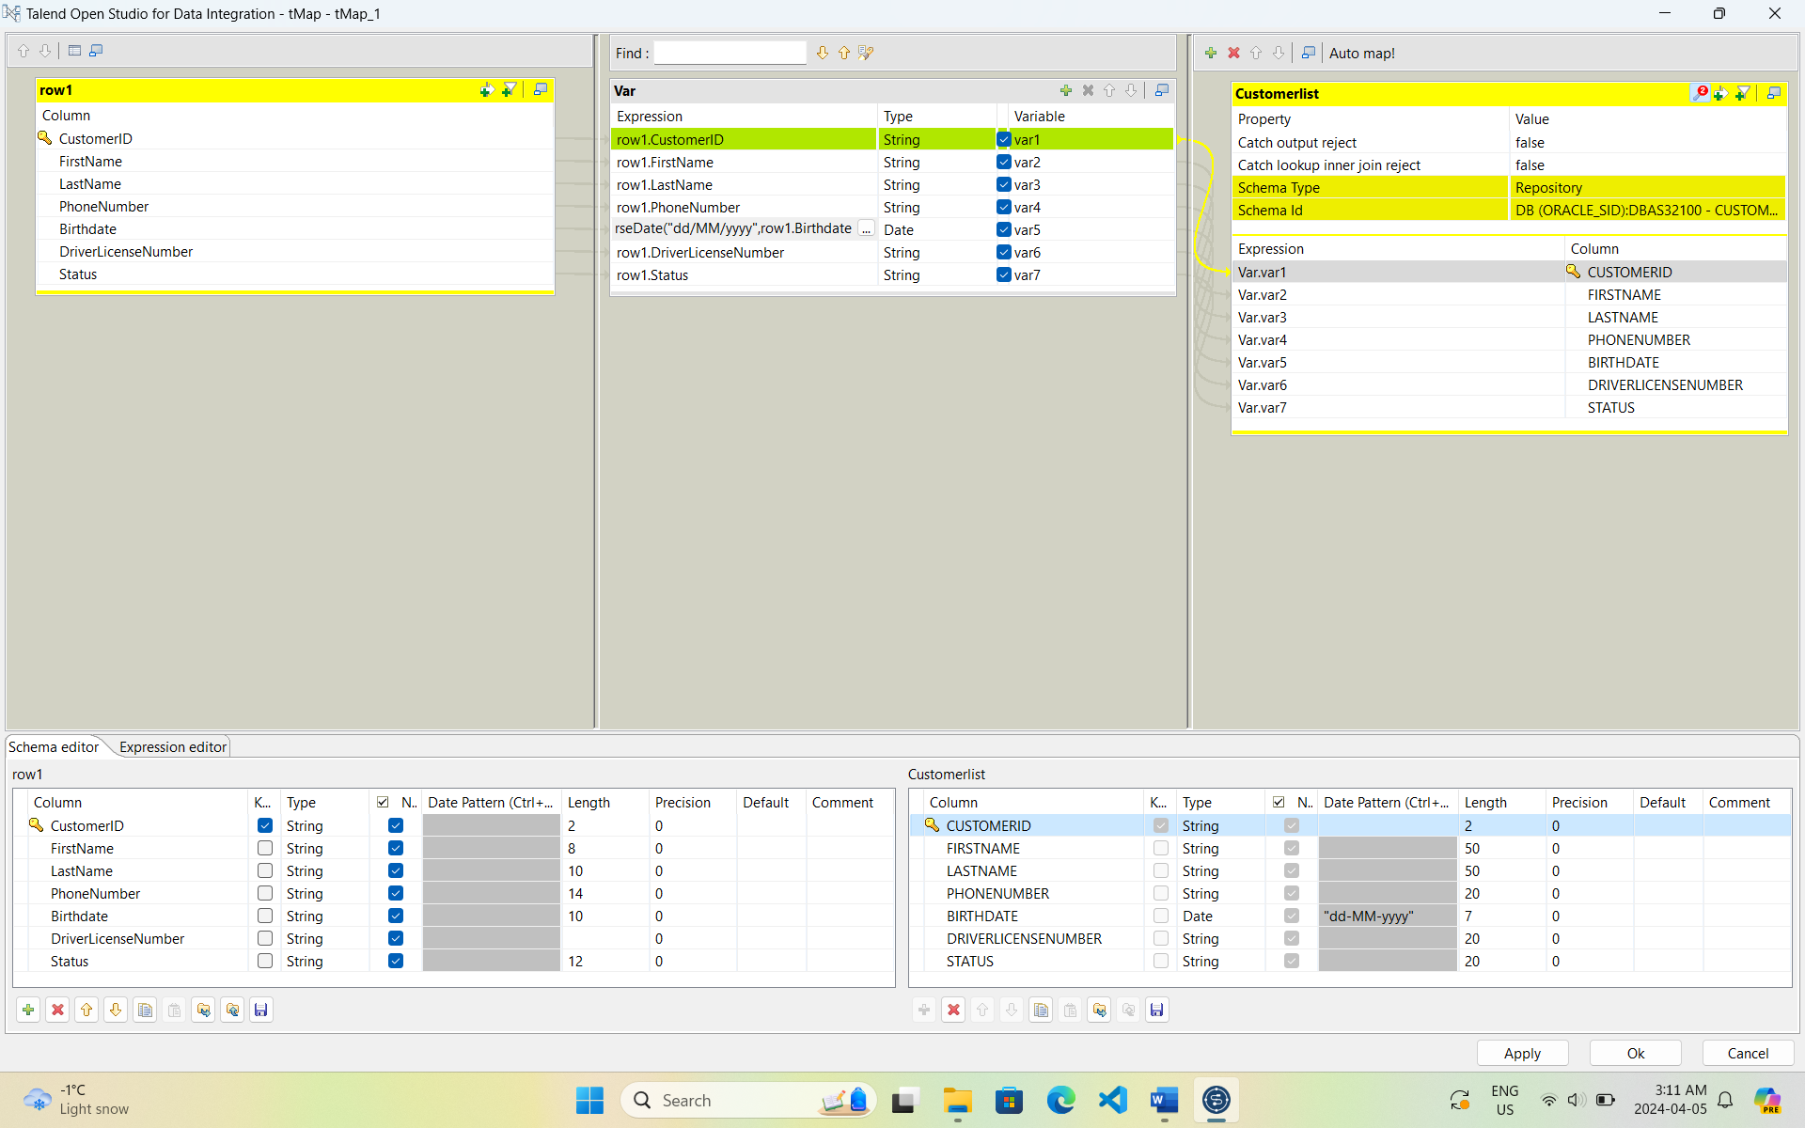

Running the Job for Customer_List Table

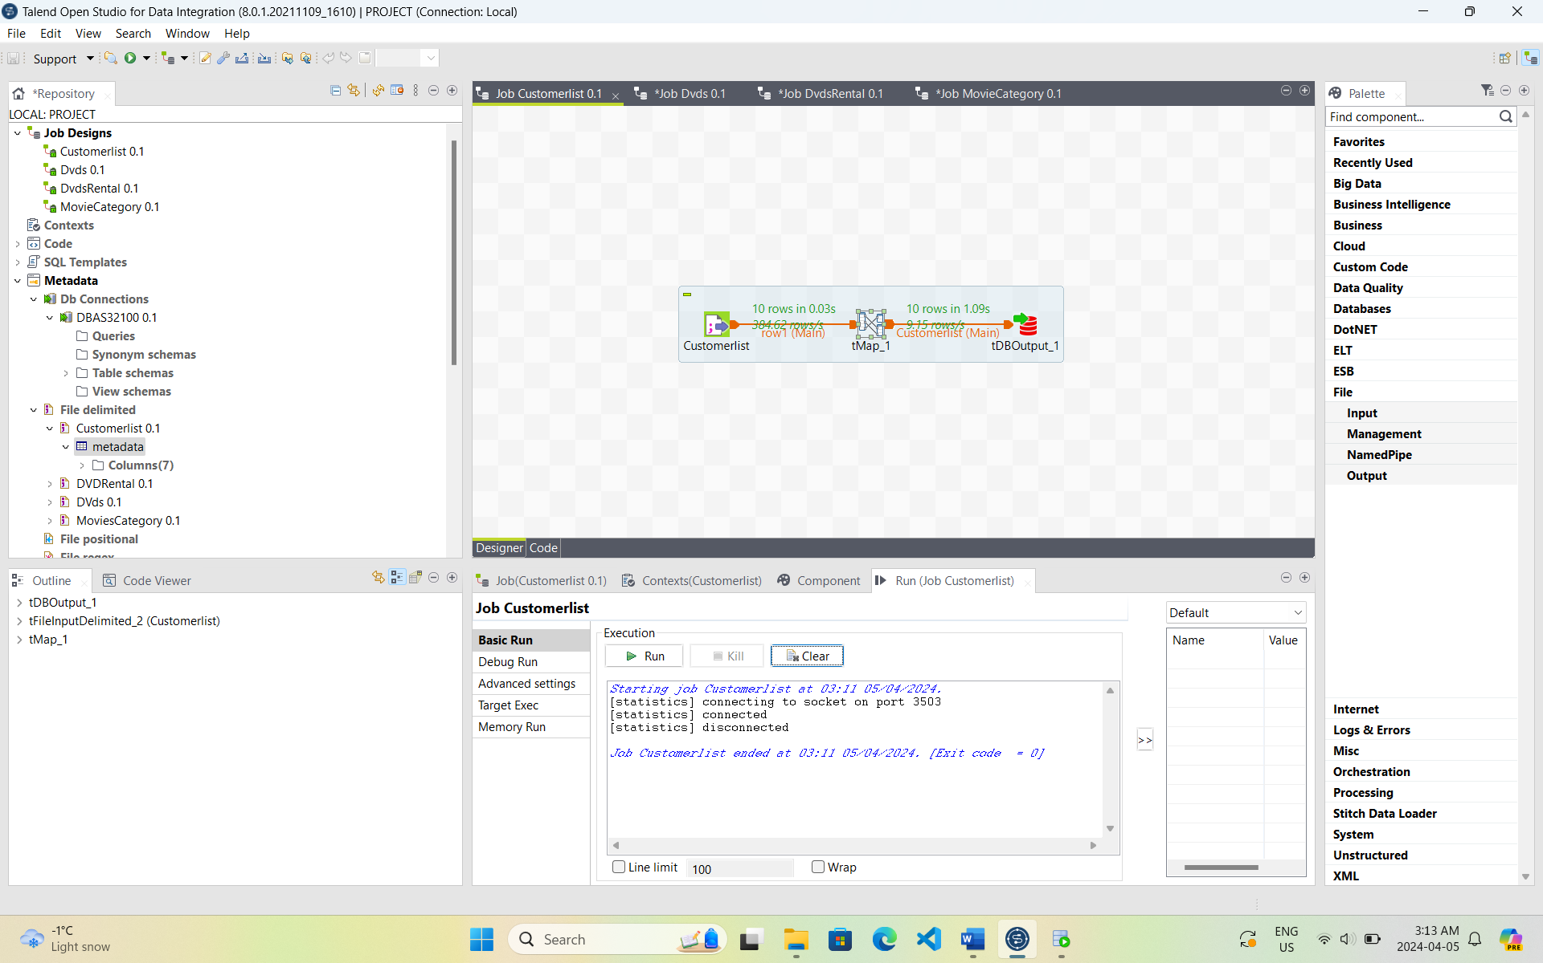

# Display Data in SQL Developer: Once the data is imported we used SQL Developer to query and display the data in the created tables. This step helped us verify that the data import process was successful and that the tables contain the expected data.

## Movie Category Table

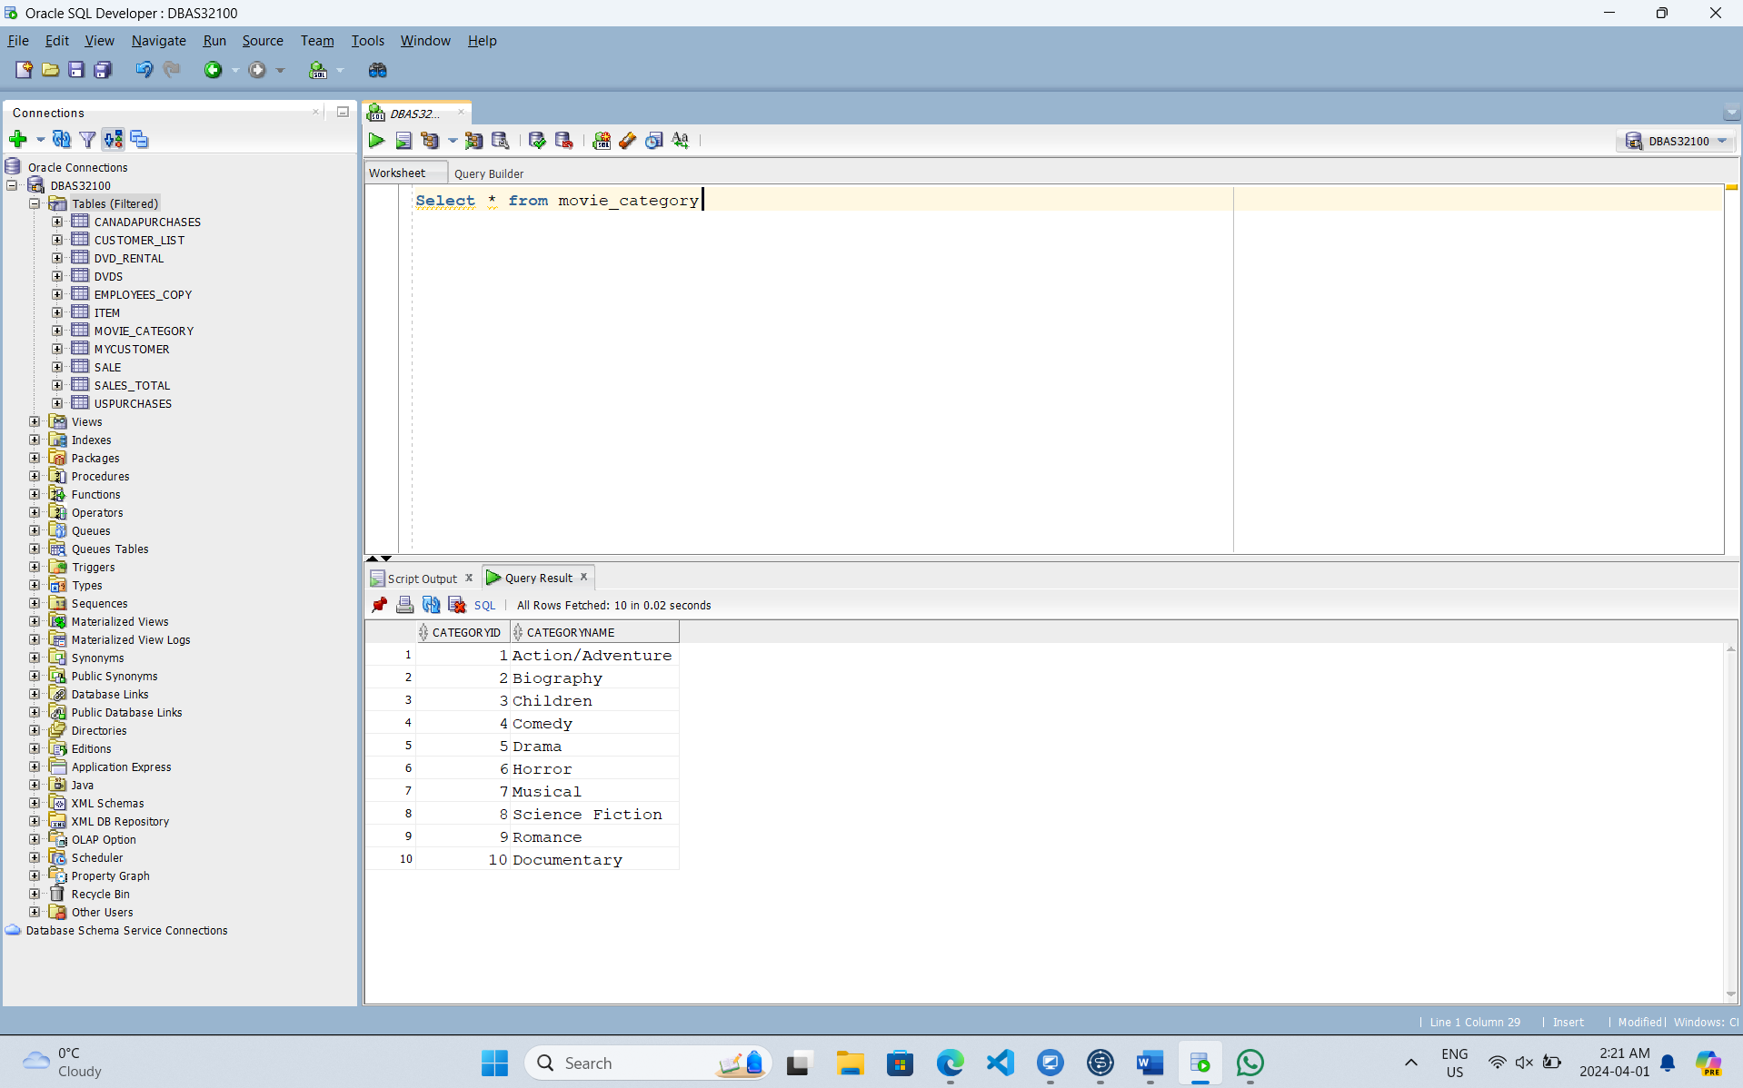

Dvd’s Table

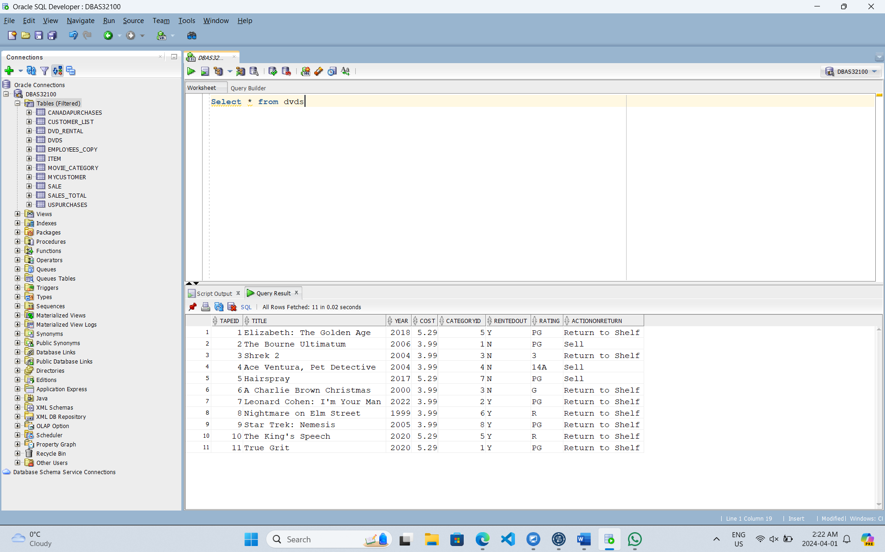

## Dvd Rental Table

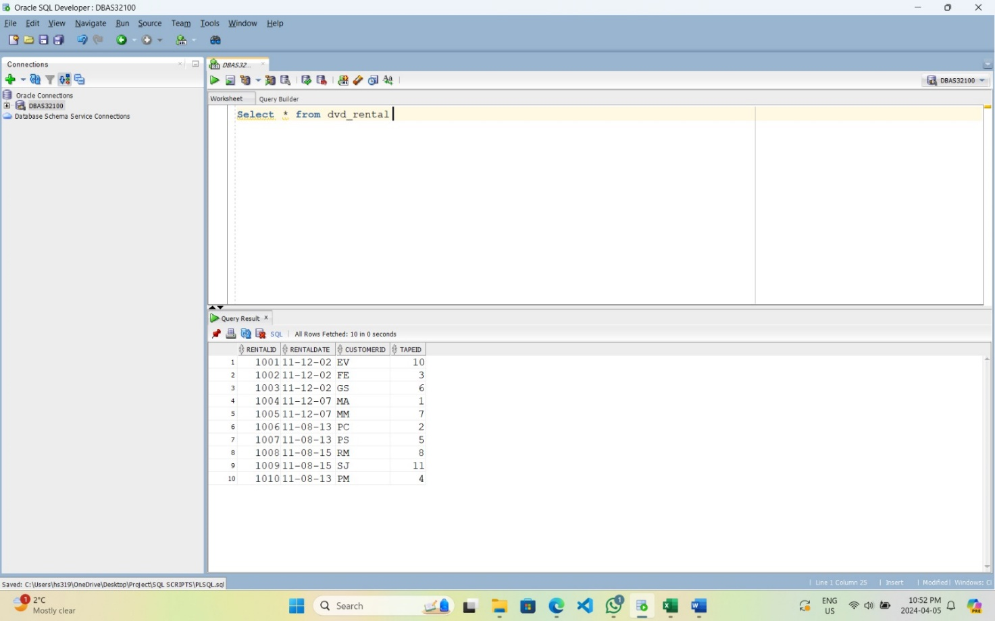

Customer List Table

In Part B of the project we focused on executing PL/SQL scripts for various operations and answering specific questions using SQL queries. This included writing scripts for insert, update, and delete operations, as well as addressing queries related to available movies, rental costs, customer rentals, and DVD details. These scripts were designed to manipulate data efficiently within the database system.

Completed by: Harsimranjit Singh

Insert Data in Movie Category Table

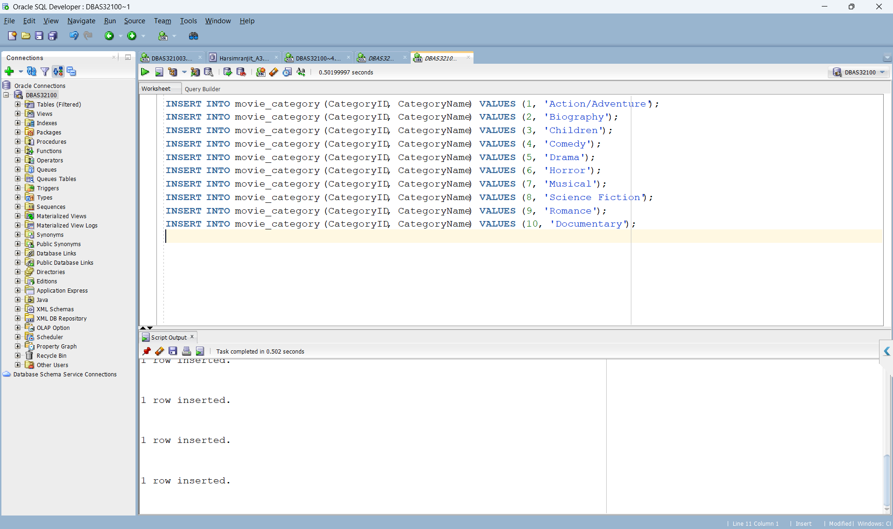

Insert data in Customer List Table

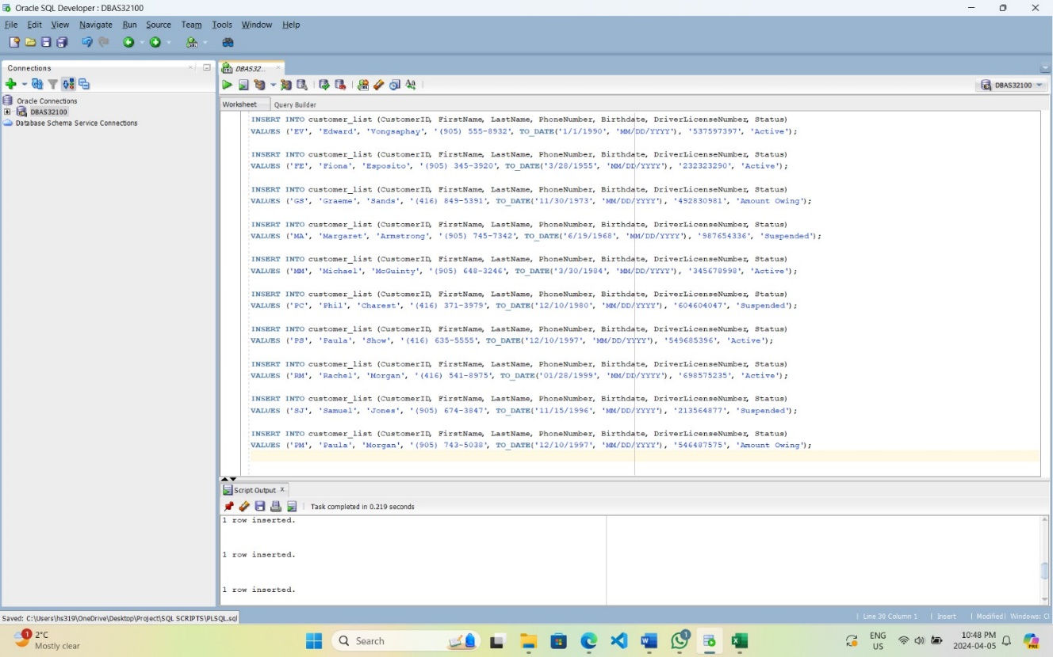

Insert data in DVDs Table

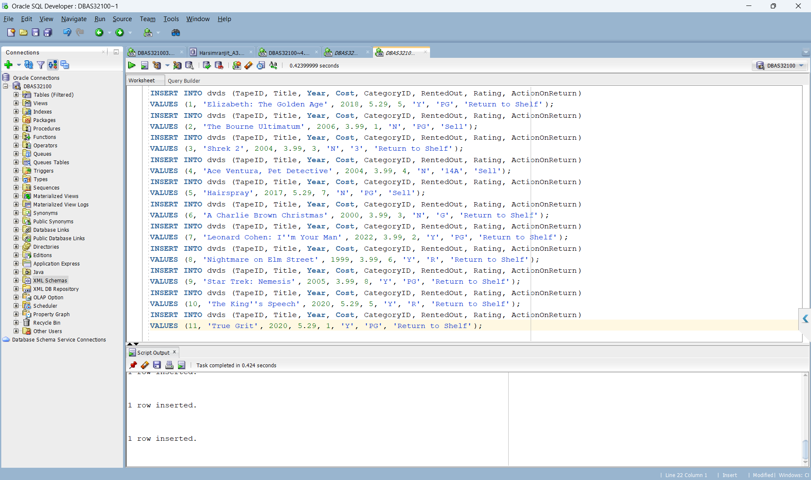

Insert data in Dvd_Rental Table

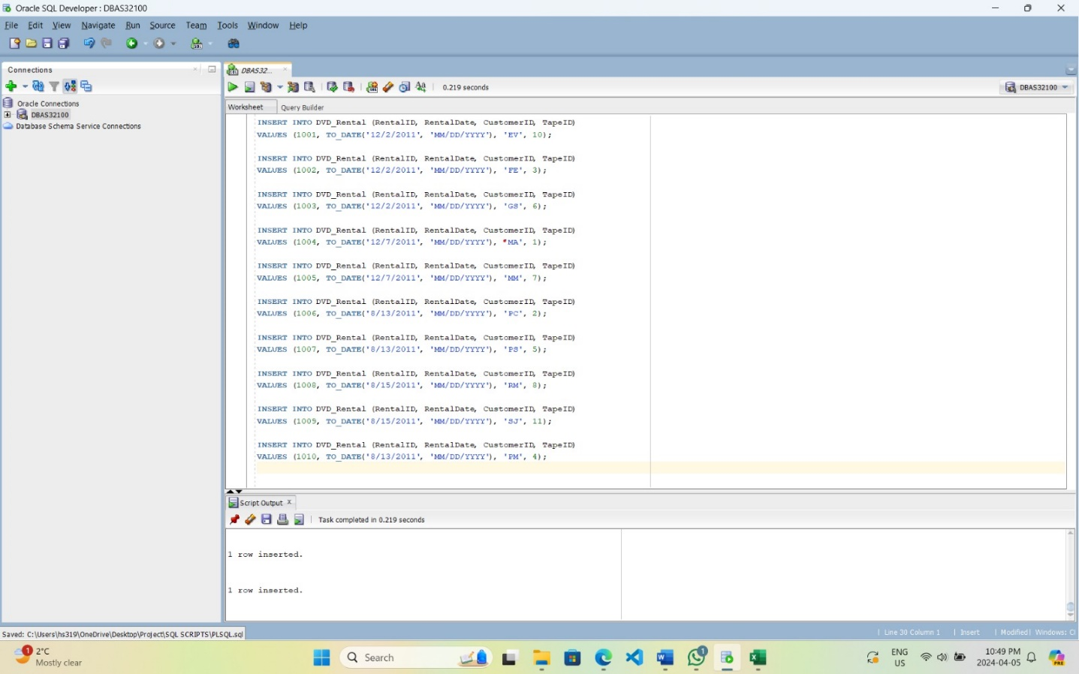

Updated Data in Customer List Table. We did that in other tables as well.

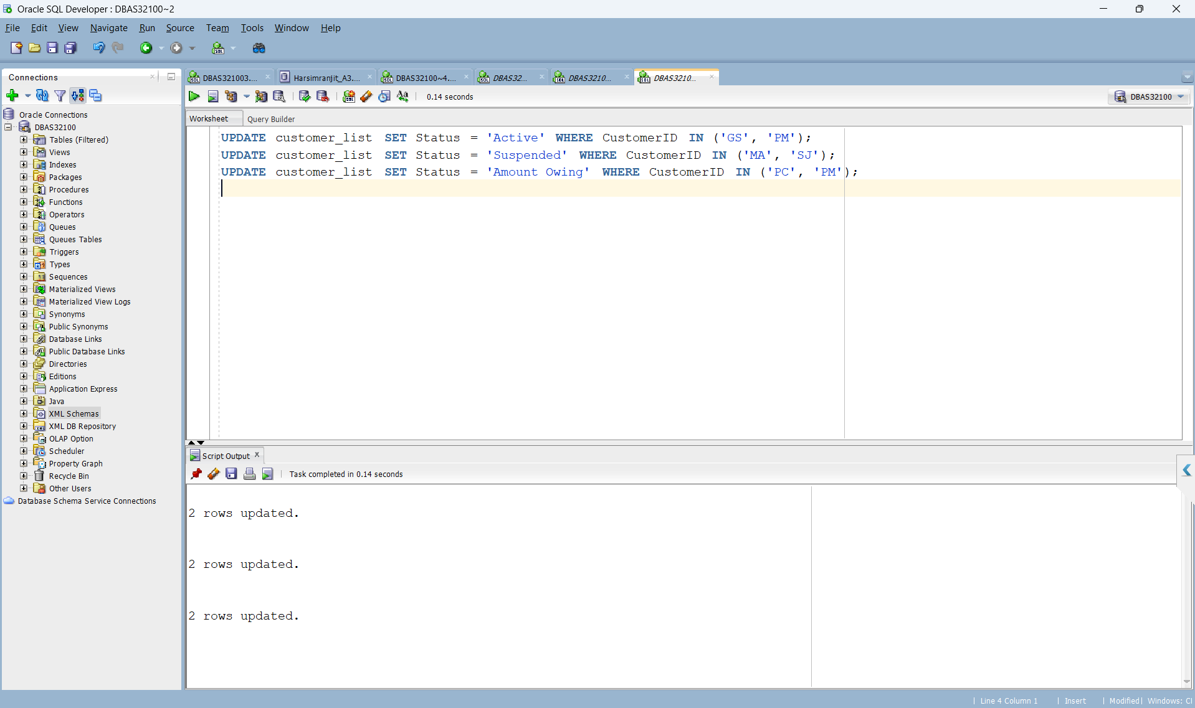

Deleted Data in Dvd Rental Table. We did that in other tables as well.

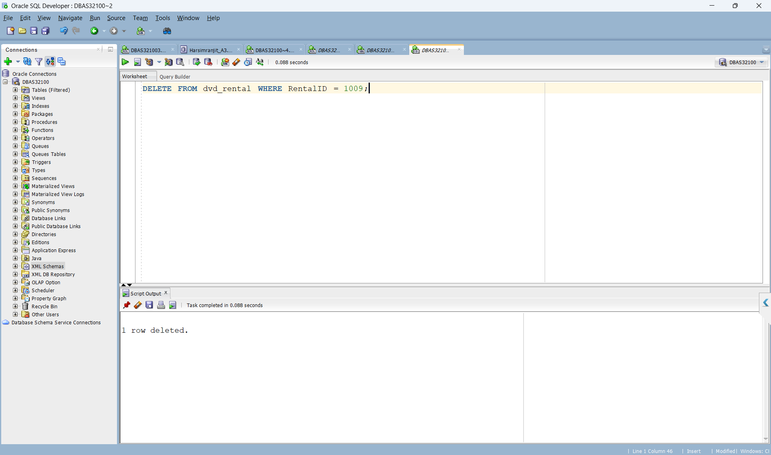

1. Which movie(s) is/are available right now to rent out?

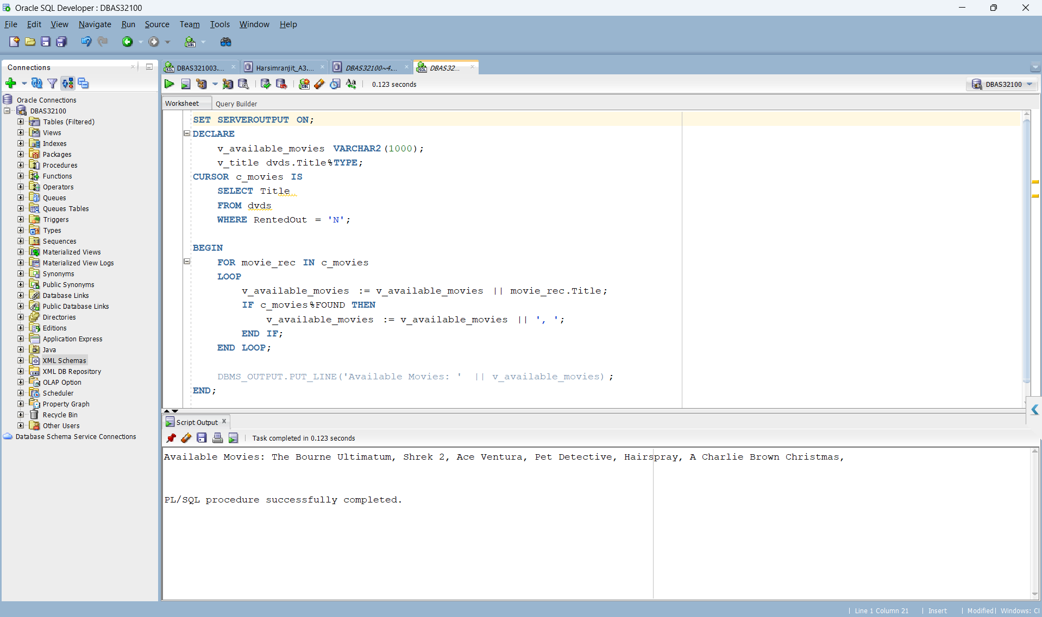

In this query we used cursor c_movies to specifically identify movies that are currently available for renting. By filtering the dvds table based on the RentedOut status being 'N' (not rented out) we displayed that only movies available for rental are displayed. The selected movie titles are linked into v_available_movies which is then output to display the list of available movies.

1. Show the movie’s which has least renting cost and highest renting cost?

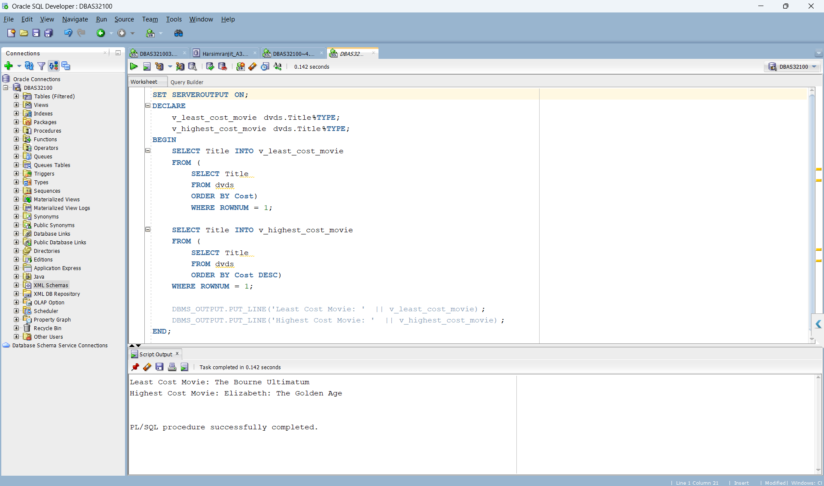

In this query we used two separate SELECT statements within a PL/SQL block to find the movie with the least and highest rental costs from the dvds table. The first SELECT statement retrieves the title of the movie with the lowest cost by sorting the table in ascending order based on the COST column and selecting the top row. On the other hand the second SELECT statement retrieves the title of the movie with the highest cost by sorting the table in descending order based on the COST column and selecting the top row.

1. Show all the detail of a customer and the movies they are renting.

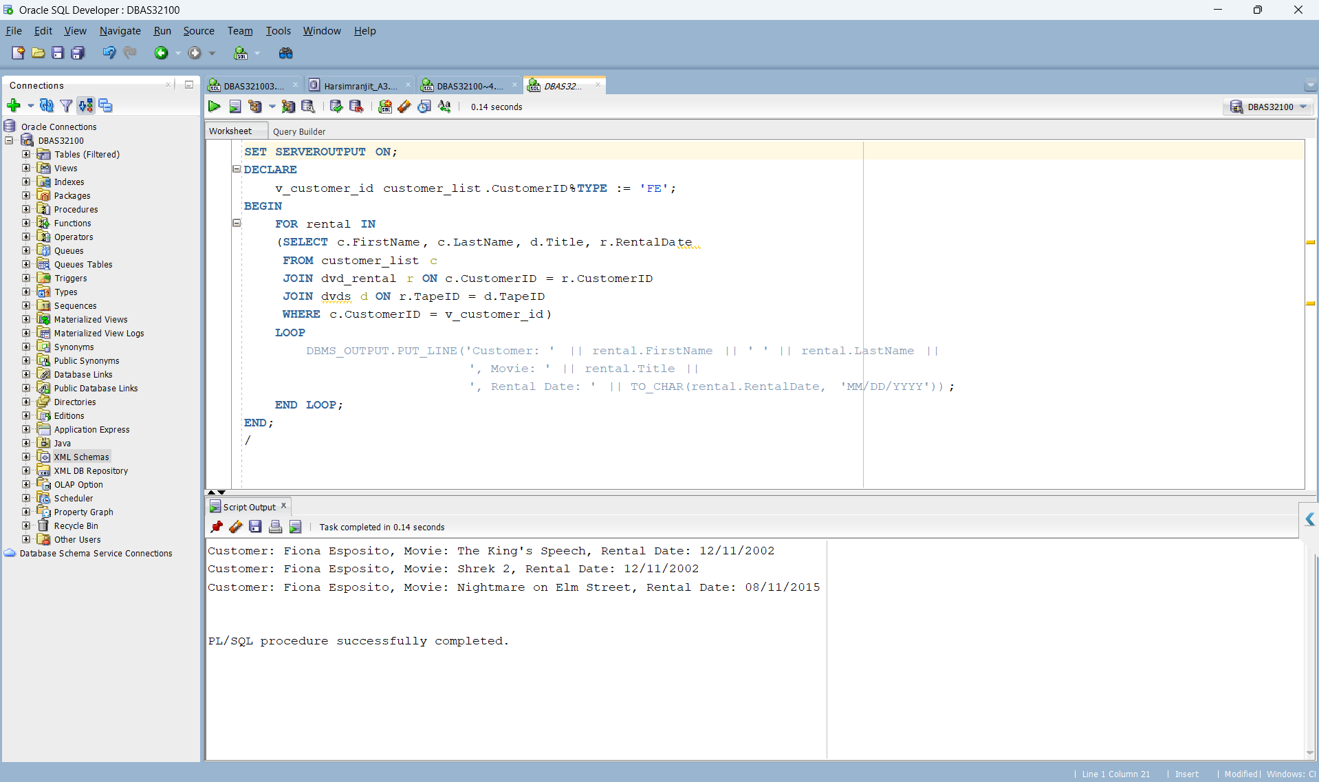

We used SQL queries within a PL/SQL block to fetch detailed information about a specific customer's rentals from the customer_list, dvds, and dvd_rental tables. By joining these tables based on the customer's ID we retrieved data such as the customer's FirstName and LastName, the titles of the movies they are renting and the rental dates.

1. Show the names of the customers and the number of movies rented by them.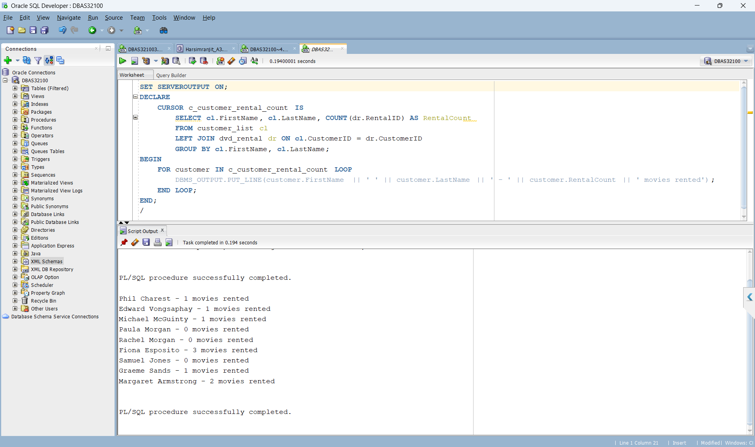

We used cursor c_customer_rental_count to calculate the number of movies rented by each customer. This cursor joins the customer_list and dvd_rental tables grouping the data by customer’s first and last name and counting the number of rental IDs linked with each customer. The output displays the customer's first name, last name, and the total number of movies they have rented.

1. What is the difference between DVD cost and the average cost of all the DVDs of each year.

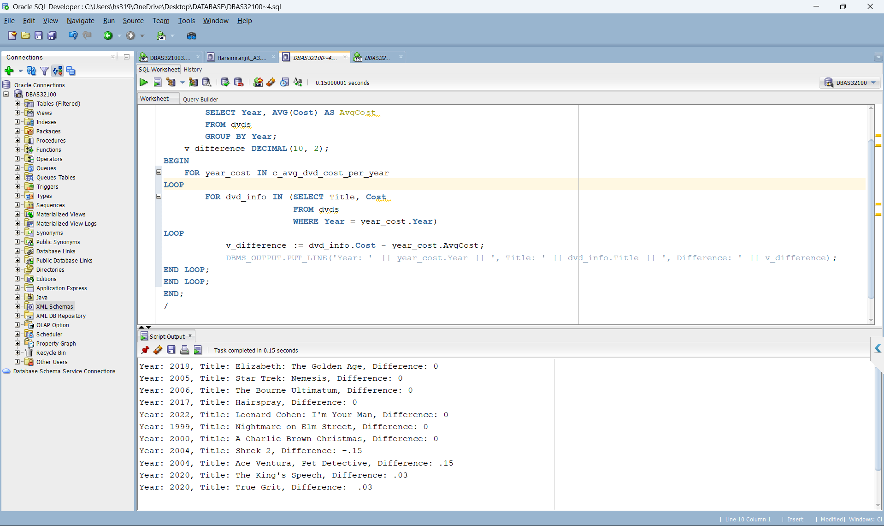

We used cursor c_avg_dvd_cost_per_year to calculate the difference between the cost of DVDs and the average cost of all DVDs for each year. The cursor selects the year and the average cost of DVDs for that year from the dvds table then it loops through each DVD in the same year calculating the cost difference between the DVD and the average cost.

1. Show the titles and cost of DVDs who are with third and fourth highest price.

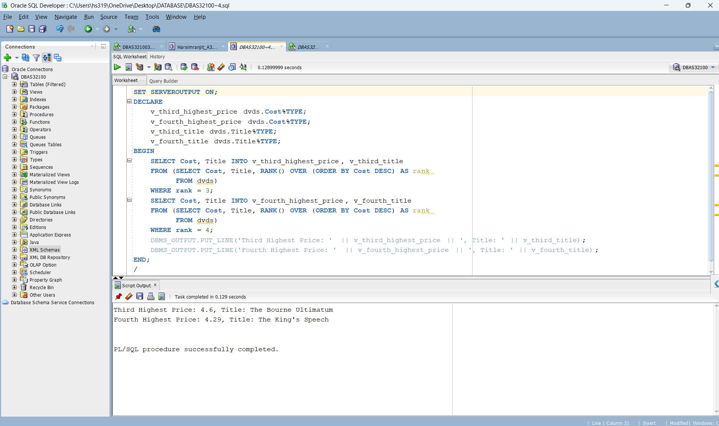

We used SQL queries with analytic functions such as RANK and OVER to identify DVDs with the third and fourth highest prices. By ranking DVDs based on their costs in descending order we confined the third and fourth highest-priced DVDs.

1. Show the first name, movie name and cumulative prices for each movie in the increasing order.

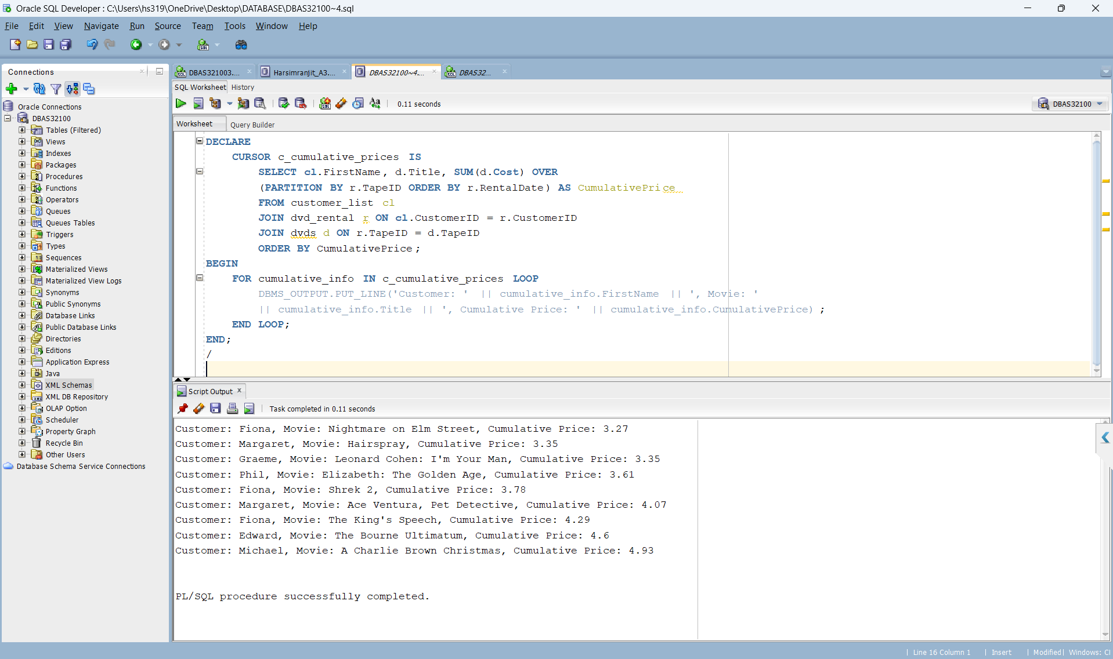

We used cursor c_cumulative_prices along with SQL queries and analytic functions. The cursor looped through the results retrieved by using the SUM function with the OVER clause partitioned by the TapeID and ordered by RentalDate within the SQL query. Thus we calculated the cumulative prices for each movie.

Part C involves examining the DVD table to figure out what aspects were important for creating a Star Schema and ER diagram. We focused on dimensions like Movie Category, Title, Year, Action On Return, and Rating. Also, we made a fact table to track the cost of each DVD, using Fact ID as the primary key and other attributes as surrogate keys.

Completed By: Harleen Kaur

Q. Consider DVD table of from the excel sheet. What can be the possible dimensions and facts in this table? Explain.

These can be the possible dimensions and facts in this table:

Title (DIM_TITLE): Represents the titles of dvds.

Year (DIM_YEAR): Represents the release years of dvds.

Category (DIM_CATEGORY): Represents the categories or genres of dvds.

Rating (DIM_RATING): Represents the ratings assigned to dvds.

Action on Return (DIM_ACTIONONRETURN): Represents the actions taken upon DVD return such as late return, damage, or loss.

Facts:

Cost (FACT_DVDS): Represents the cost associated with each DVD.

Rented Out (FACT_DVDS): Represents whether a DVD is currently rented out ('Y') or available for rent ('N').

Creating Dimension Tables

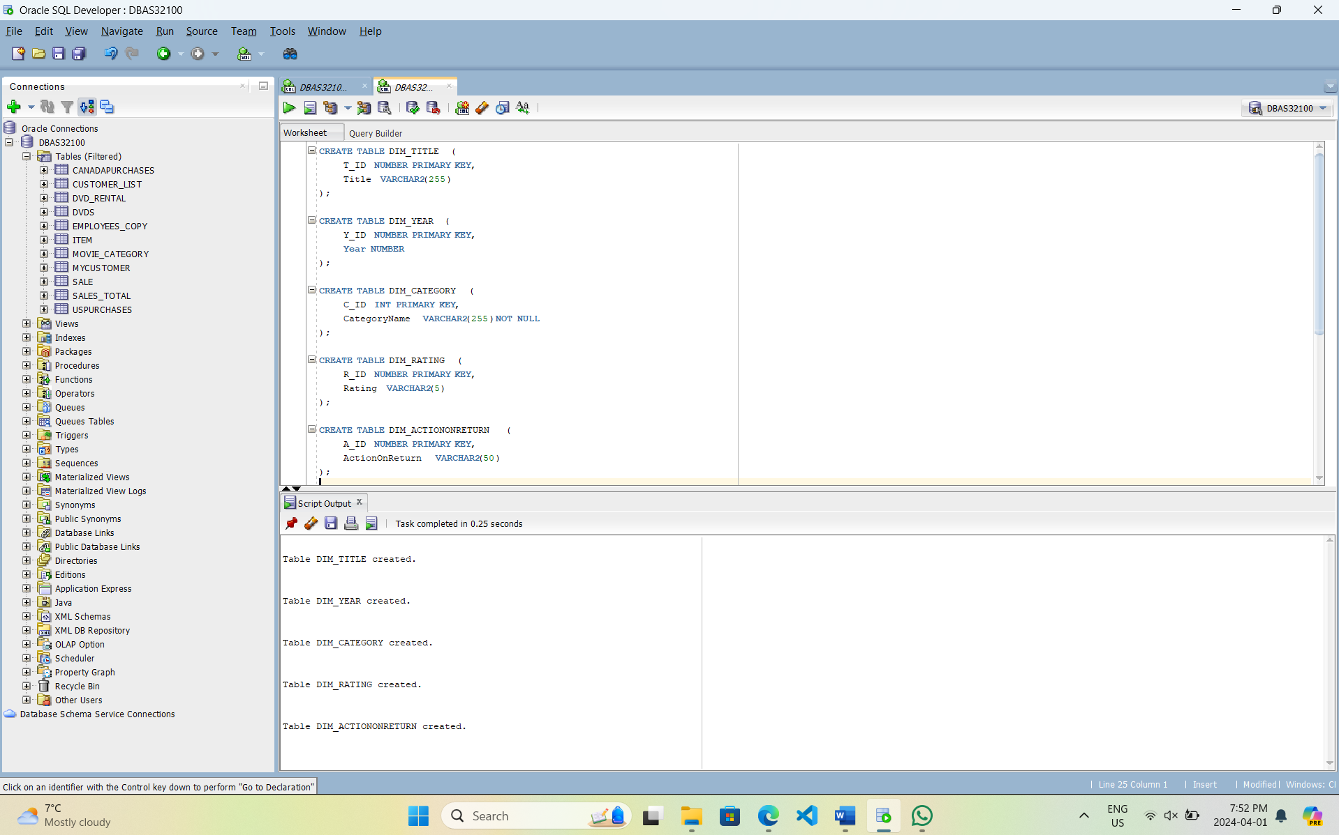

Populating each dimension table involved extracting relevant information from the Dvds table and inserting it into the corresponding dimension table.

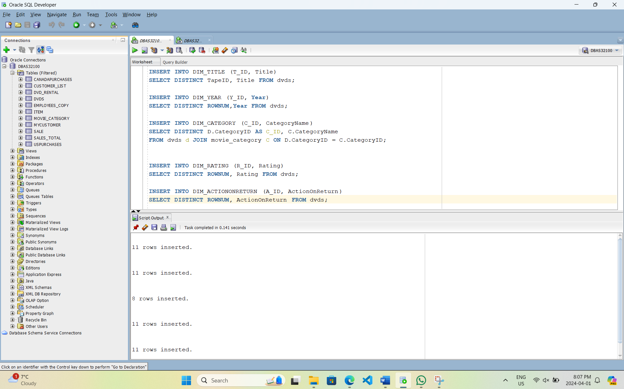

Queries to check output of all Dimension Tables:

Dim_Title

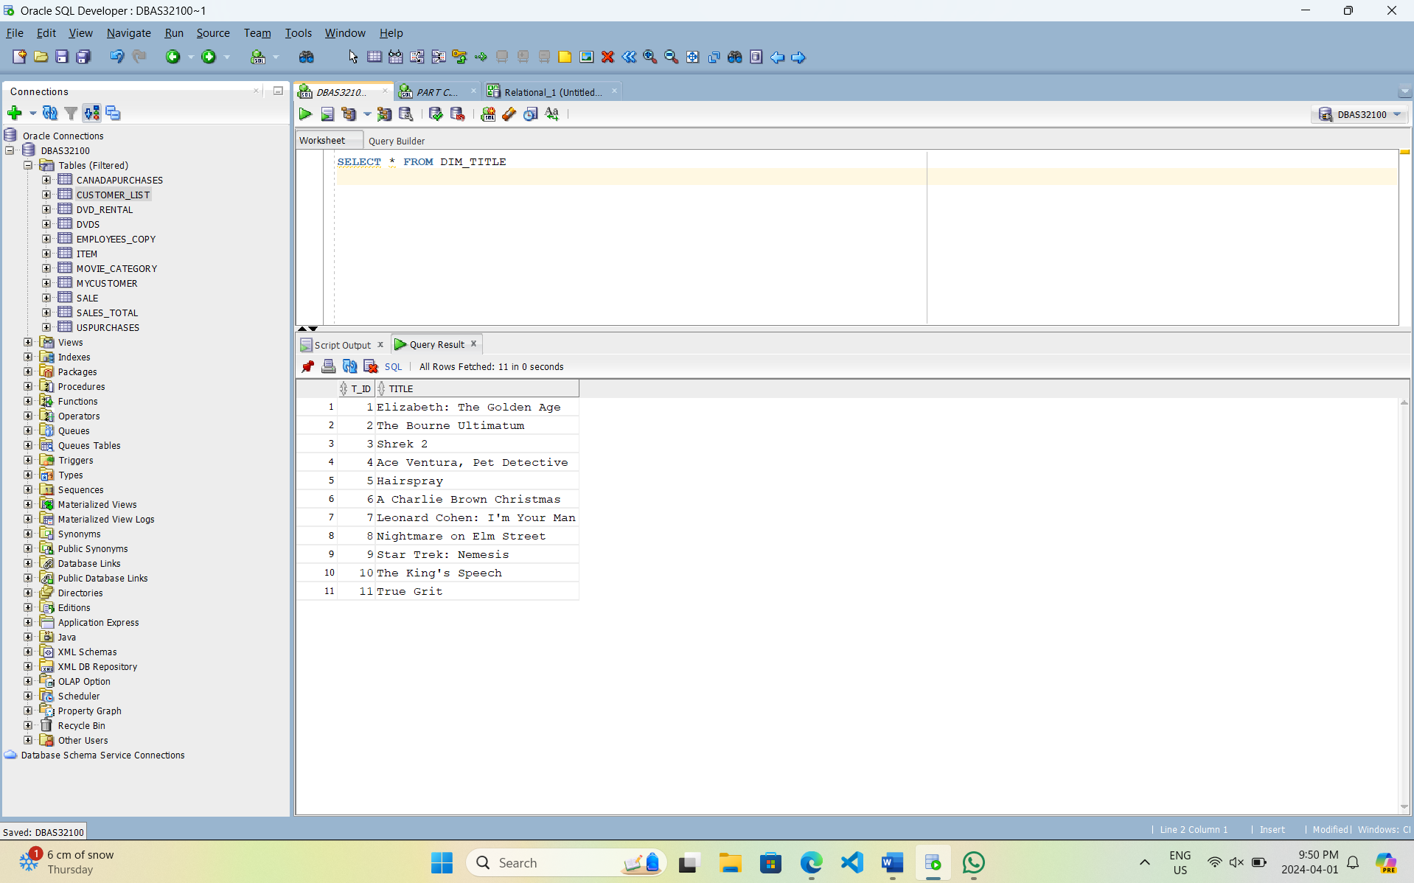

Dim_Year

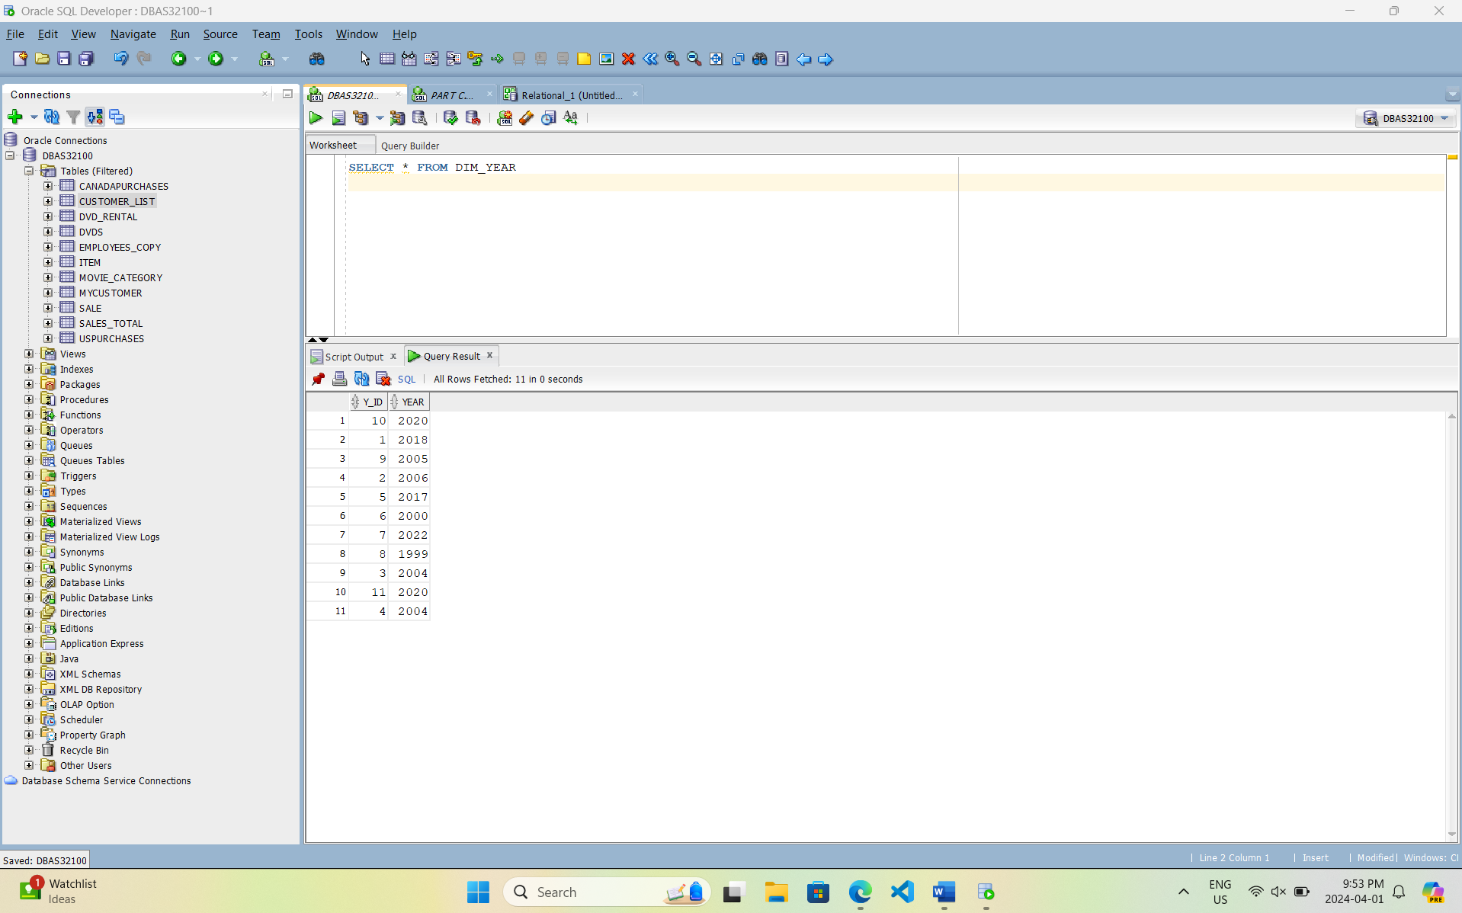Dim_Category

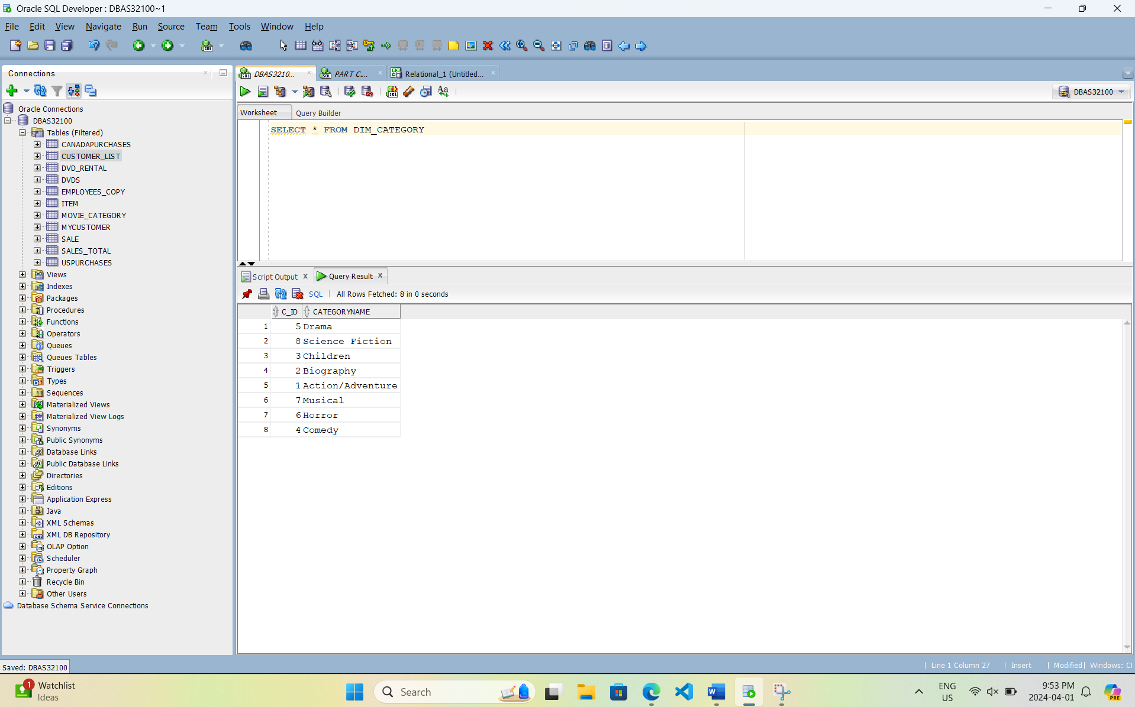

Dim_Rating

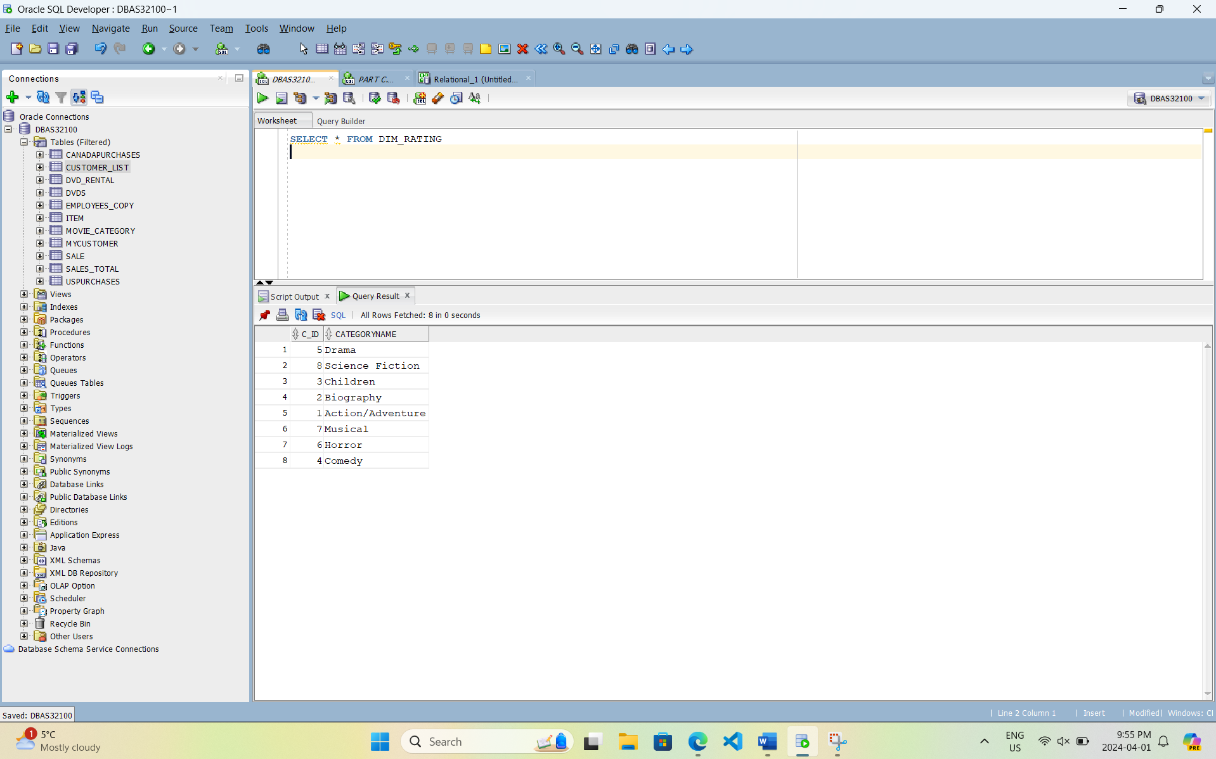

Dim_ActionOnReturn

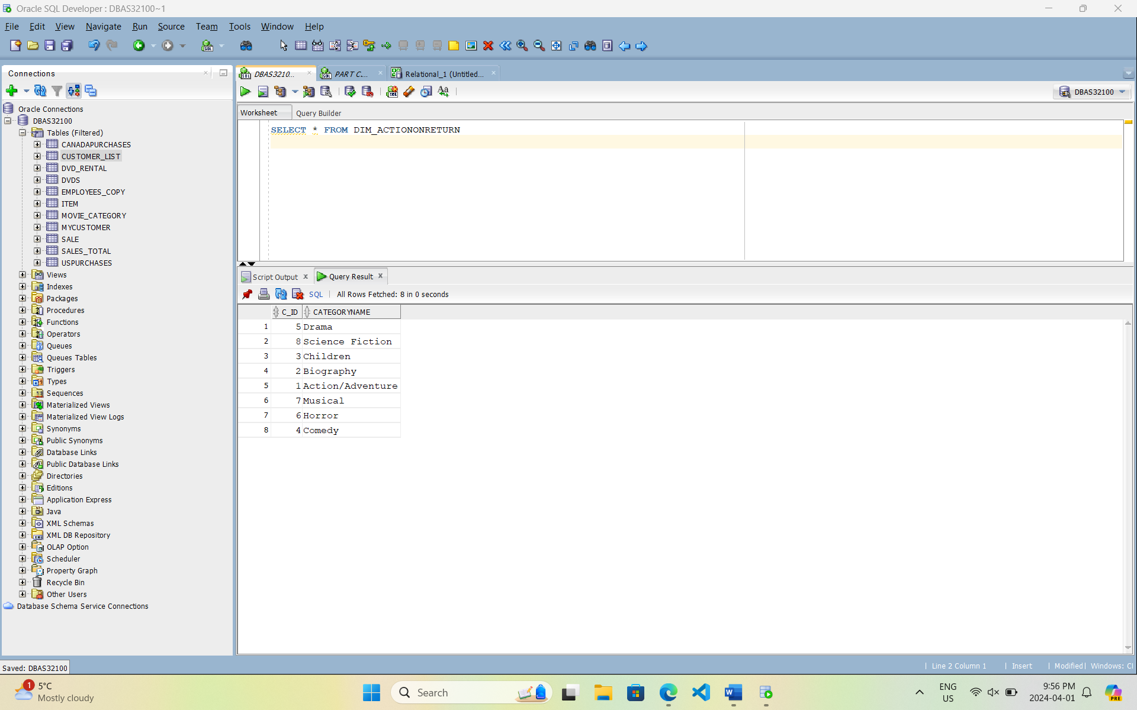

Creating the Fact_dvds table with Fact_ID as primary key and T_ID, Y_ID, C_ID, R_ID AND A_ID, specific data types

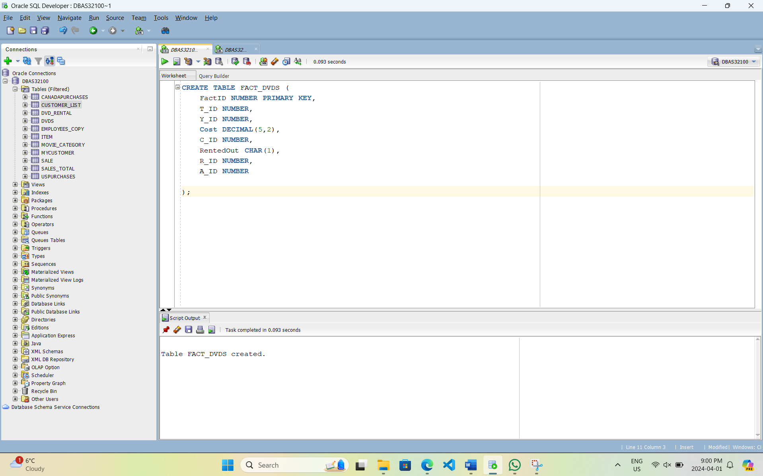

Populating the Fact_dvds Table

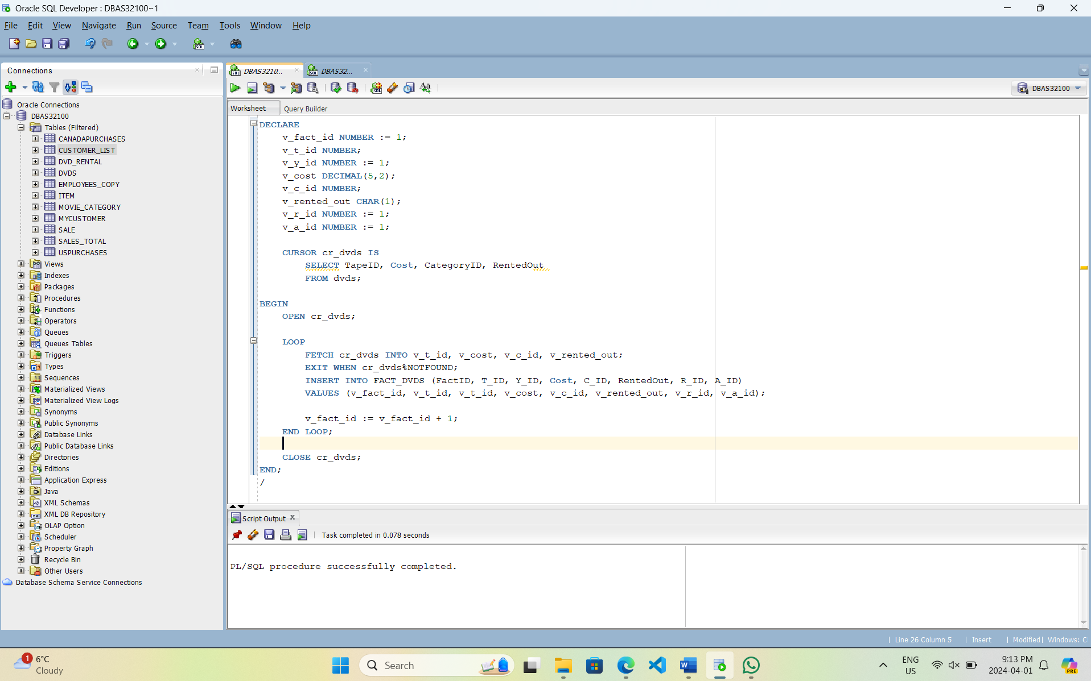

In this we populated Fact_dvds table with appropriate values from the Dvds table. We used cursor cr_dvds retrieve essential data like TapeID, Year, Cost, CategoryID, Rating, ActionOnReturn, RentedOut and Status. Each fetched value is then inserted into the fact table. The unique FactID assigned to each record helps in data organization and analysis within the Star Schema.

Queries to check output of Fact_Dvds

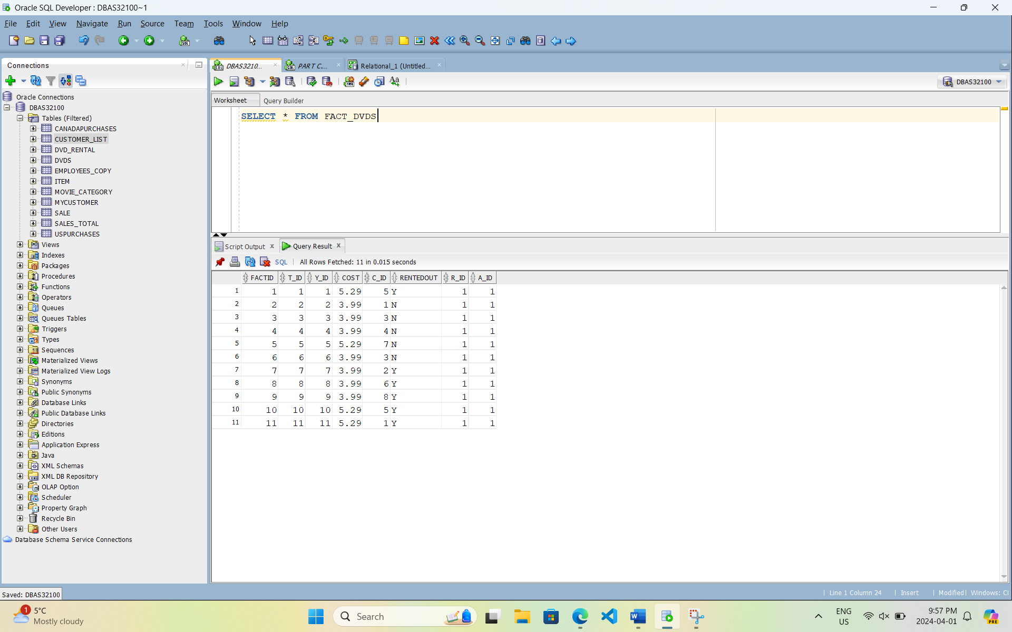

Using query to check fact_dvds data

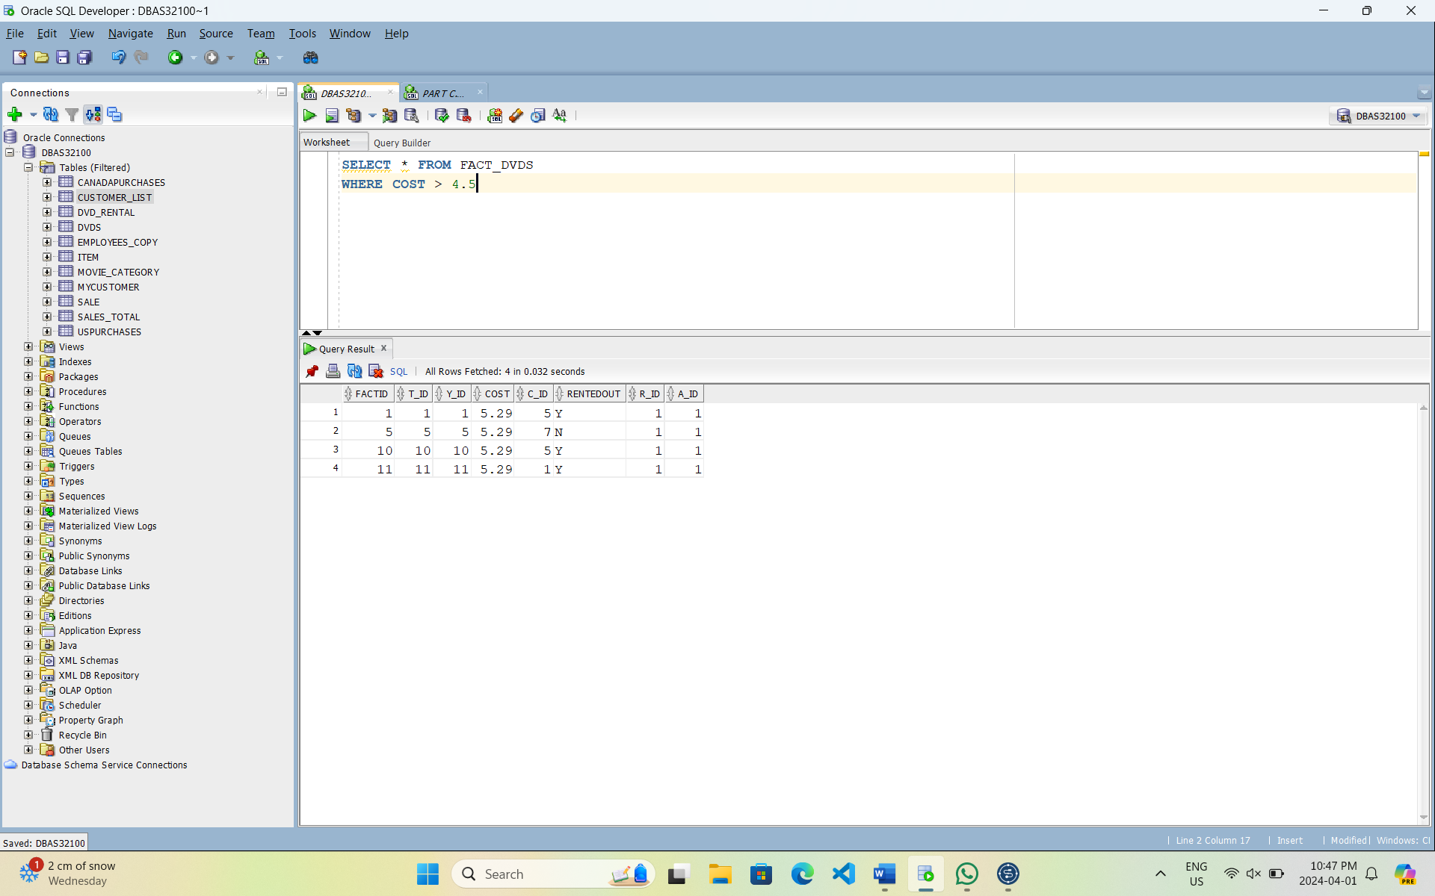

Q. Create a Star Schema and an ER diagram (using draw.io) out of DVD table, to find out the total amount of cost for each category, each year and Rating.

Star Schema

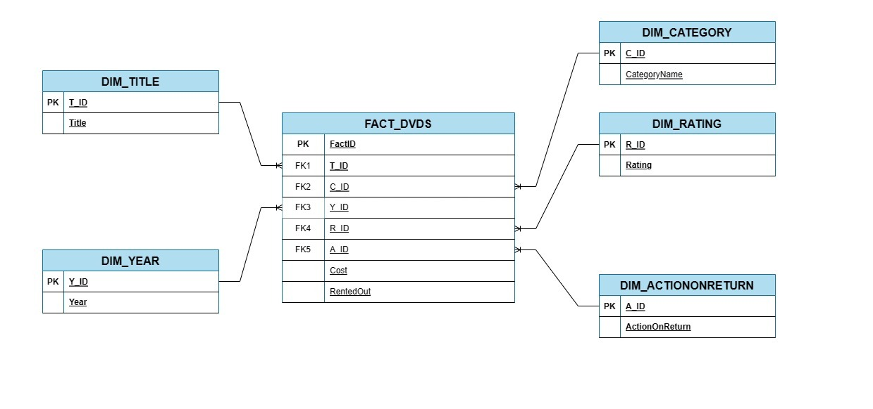

ER Diagram

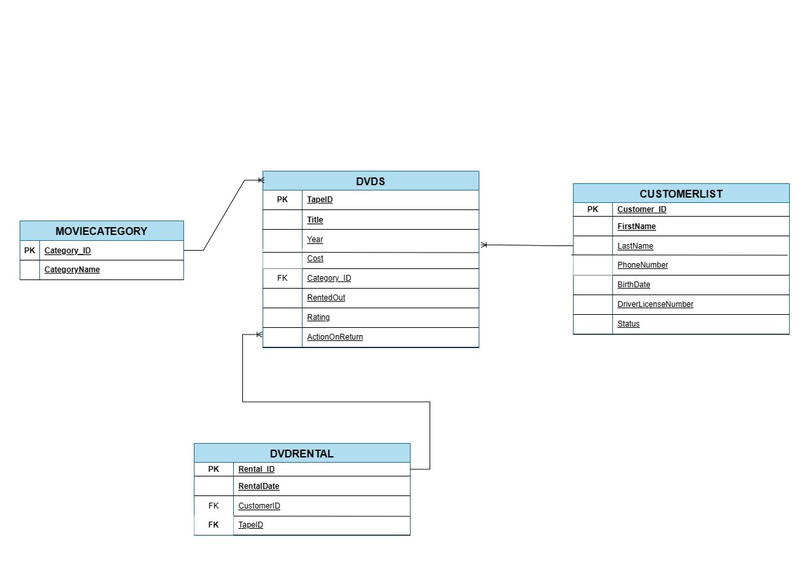

Total cost for each category

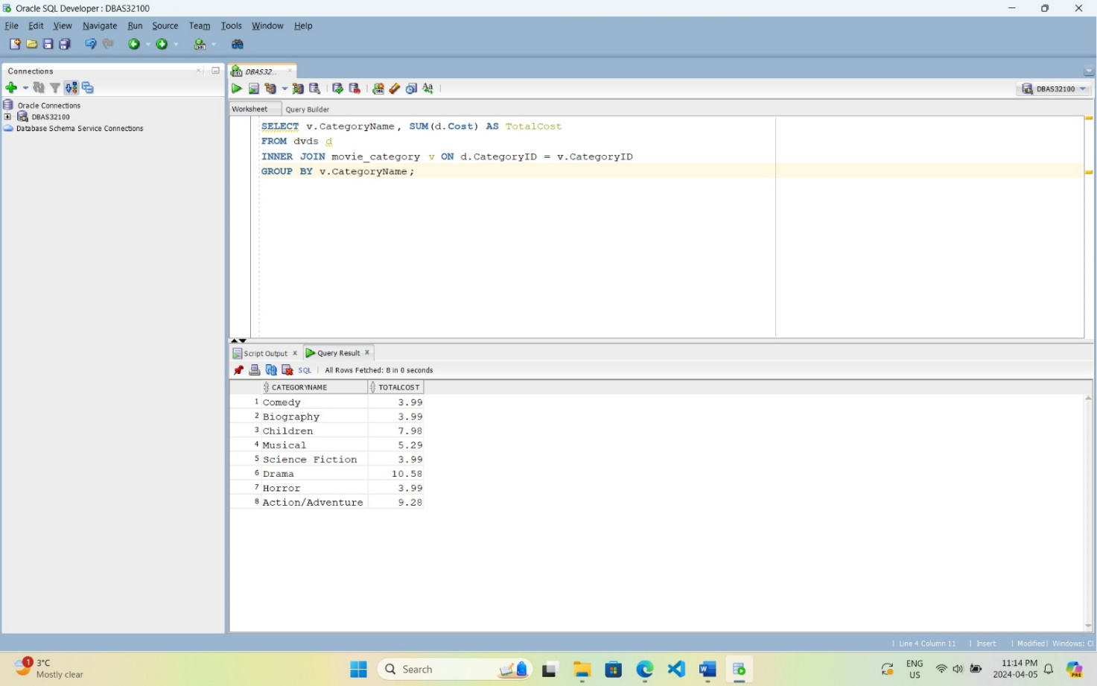

Total cost for each year

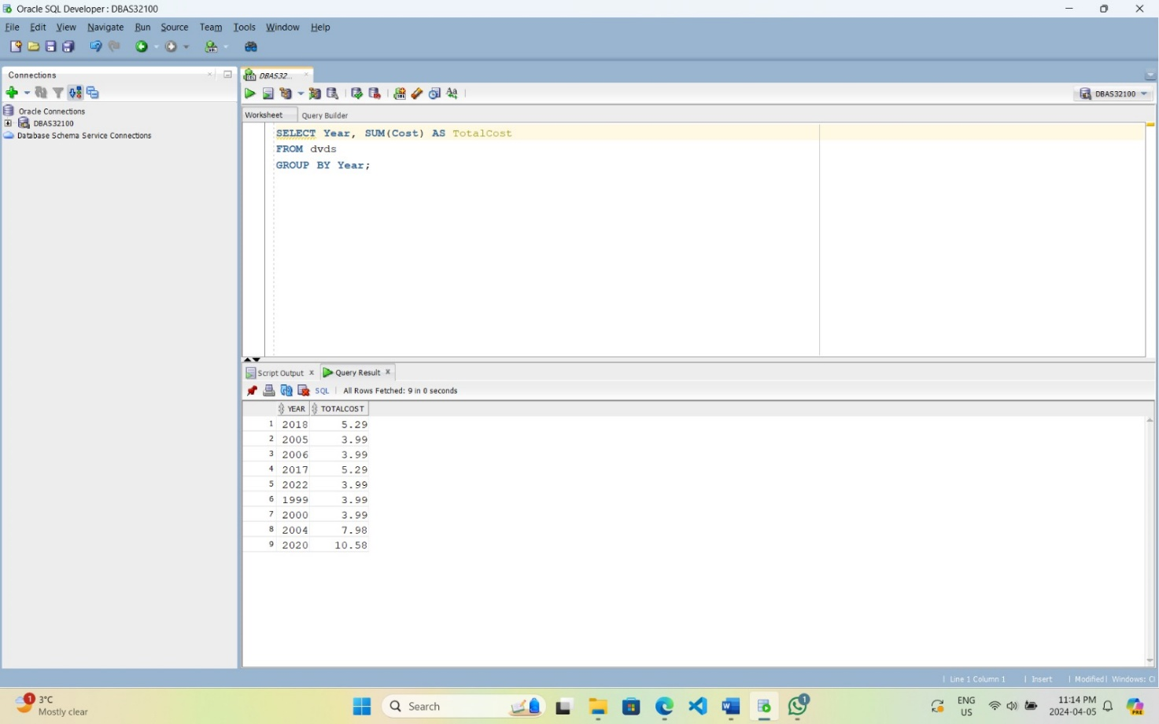

Total cost for each rating

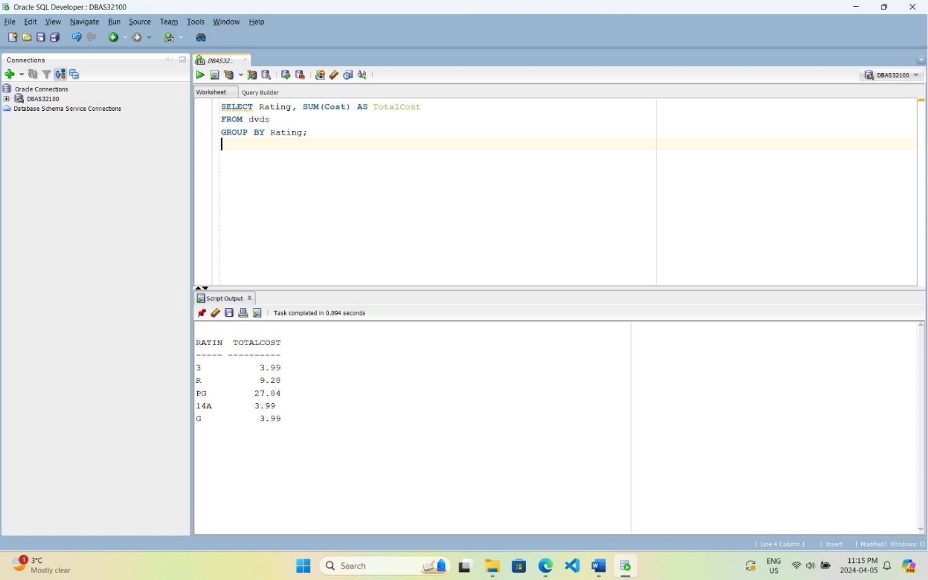

Using query to check fact_dvds data linked in dim table.

